Press Release

LogiMAT trade fair:
Embedded vision for intralogistics

Vision Components will present smart components, sensors and imaging technologies for OEM intralogistics projects at the LogiMAT trade fair in Stuttgart, Germany, at booth #4-C26. The product range includes versatile camera modules, electronics kits for customized vision sensors as well as turnkey solutions that take image processing, machine vision and AI to the shop floor and logistics. An OEM product based on a VC embedded vision system will be on show: Vision Components‘ partner Retenua has realized a fully autonomous driver-assistance system that detects reflectors on high-visibility clothing, calculates the 3D position and speed of people and triggers an alarm to the driver if an accident threatens. The emitrace sensing and processing unit is typically installed at the rear of industrial vehicles and connects to an optoacoustic signaling device in the driver’s cabin. No other devices are necessary. Optionally, if coupled with the vehicle control system, emitrace can even directly initiate braking. It is available as an OEM component for logistics applications.

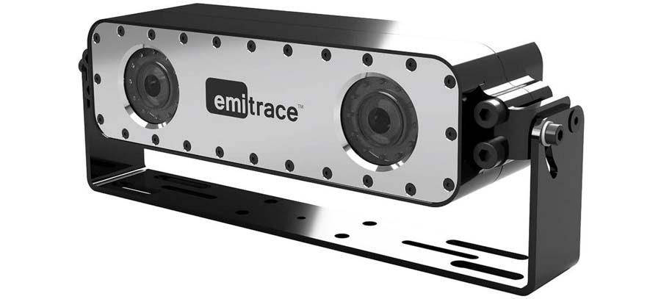
Caption: Vision Components supplies rugged standalone solutions, customized systems and modular kits for integrating embedded vision in intralogistics, transportation and automation. The emitrace driver-assistance system from Retenua uses VC components and is designed for demanding industrial environments.

Embedded vision brings along a high data depth and thus opens up entirely new possibilities and smart applications for camera sensors in intralogistics – from barcode reading to fully automated measurement of parcels, to self-driving, autonomously navigating transport robots. Vision Components supplies OEMs both with economic camera sensors for industrial applications for quick and easy combination with all common embedded platforms, and deeply integrated standalone systems uniting image capture and processing. All of these products are designed for flexible integration in OEM designs for all kinds of applications. They are rugged and long-term available. Exhibits include tested and proven dedicated sensors for barcode reading, object detection and measurement and other applications based on 3D laser triangulation. These are available as ready-to-use sensors with protective housings or as modular electronics kit for OEM projects.
Vision Components at the LogiMAT trade fair
Stuttgart, Germany, 31 May – 2 June 2022
Hall 4, Stand C26

Image/s: | retenua_emitrace_vc | Characters: | 2025
File name: | 202203014_pm_logimat_trade_fair_en | Date: | 03-28-2022
About Vision Components
Vision Components is a leading international manufacturer of embedded vision systems. The freely programmable cameras with powerful onboard CPUs perform image processing tasks on their own without the need for an additional computer. Vision Components offers OEMs versatile Linux-based embedded systems for 2D and 3D image processing, supplied as board cameras or in protective casings. These are complemented by a growing range of ultracompact MIPI camera boards, which connect to a variety of different CPU boards. In addition, Vision Components offers software libraries and develops customized solutions on request. The team of experts can draw on extensive knowledge and over 20 years of experience with imaging applications. The company based in Ettlingen in southwestern Germany was founded in 1996 by Michael Engel, the inventor of the first industrial-grade intelligent camera. More world premieres followed, including the world's first intelligent vision sensors and the first-ever embedded 3D laser profiler. Today, Vision Components has sales offices in the United States and Japan and works with local partners in over 25 countries to provide consistent customer focus and readily available expertise throughout the world.
Contact:  Vision Components GmbH  Jan-Erik Schmitt  Ottostr. 2  76275 Ettlingen  Germany  Phone: +49 . 7243 . 21670  Email: schmitt@vision-components.com  Internet: www.vision-components.com |  | gii die Presse-Agentur GmbH  Immanuelkirchstr. 12  10405 Berlin  Germany  Phone: +49 . 30 . 538 9650  Email: info@gii.de  Internet: www.gii.de

