Press Release

LogiMAT trade fair: intra-logistics innovations by LOSYCO

LOSYCO will present innovative intra-logistics and material feeding solutions at the LogiMAT trade fair (Stuttgart, Germany, 31 May – 2 June 2022, Hall 7, Stand D37). The German manufacturer will demonstrate the latest additions to its LOXrail transport system. A new version of the AllRounder steering platform enables an electrically controlled change of direction, rotation and alignment of payloads up to 15 tons on the rails, without the need to hoist transported goods. A battery-powered servomotor aligns the wheelsets. Users can switch to straight or sideways travel or a 180° about-turn at the push of a button. Another novelty on show will be the fully automatic SmartBrake module with sensor-based obstacle detection. The sensors cause the platform to automatically stop when people or objects block the track. Sensors at the rear detect the step pattern and activate the brake as soon as the operator stops pushing. Both detection methods reliably activate the brake even with protruding loads. They automatically switch functions when the direction of travel is reversed. In addition, LOSYCO will present a new way of re-routing empty rail-based trolleys and transport platforms and returning them to the start of a production line off the rails, without the use of forklifts or pallet trucks. A team of experts will inform visitors to the LogiMAT booth about the wide range of applications and configuration options of the LOXrail system. They are looking forward to discussing customer-specific best ways to approach production logistics, material flow, flow production and feeding systems.

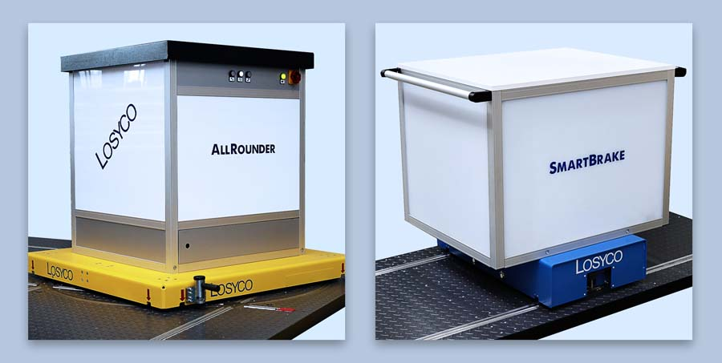
Caption: LOSYCO innovations at the LogiMAT trade fair include the automatic AllRounder steering and the SmartBrake module with sensor-based obstacle detection

Image/s: | lenkplattform-bremsmodul_2000.jpg | Characters: | 1605
File name: | 202203025_pm_logimat_en | Date: | 03-31-2022
About Losyco
LOSYCO designs, builds, and installs intra-logistics systems for the manufacturing industry. The company based in Bielefeld, Germany, was founded by experienced engineers in 2016. LOSYCO’s core product is the LOXrail® floor rail system for easy transport and precise positioning of loads weighing several tons. LOXrail transport platforms can be operated manually or with auxiliary drives. LOSYCO also supplies handling equipment such as chain and roller conveyors, material management and storage systems, as well as sound-proof cabins and machine covers. LOSYCO supports customers wishing to transform their production processes to lean manufacturing and continuous flow production. LOSYCO is a member of the DRECKSHAGE Family.
Contact:  LOSYCO GmbH  Member of the DRECKSHAGE Family  Manuel Granz  Walter-Werning-Str. 7  33699 Bielefeld  Germany  Tel.: +49 . 521 . 945 643-0  Email: info@losyco.com  Internet: www.losyco.com |  | gii die Presse-Agentur GmbH  Immanuelkirchstr. 12  10405 Berlin  Germany  Tel.: +49 . 30 . 538 965-0  Email: info@gii.de  Internet: www.gii.de

