Press Release

SECUTEST devices with updated test sequences

The latest generation of SECUTEST ST test instruments from Gossen Metrawatt is preset for the requirements of the DIN EN 50678 and DIN EN 50699 standards, which have recently come into effect. The new standards replace the DIN VDE 0701-0702, which is still valid on a transitional basis until 2022/2023. They now introduce distinct regulations for checking the protective measures for electrical safety after repair and during periodic tests. In addition, requirements for individual inspection tasks have changed. For example, a new calculation basis applies to cables over 1.5 mm² and leakage current measurement at insulated inputs is now stipulated per standard. Gossen Metrawatt has updated the range of functions of its SECUTEST ST series accordingly and expanded the scope of measurements with new standards-compliant test sequences. The manufacturer offers these new features for download to update earlier device generations.

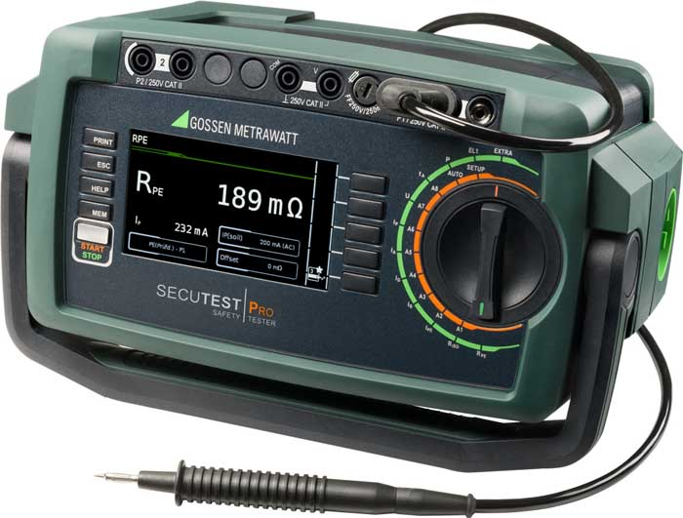
Caption: The SECUTEST ST features updated test sequences according to DIN EN 50678 and DIN EN 50699

The SECUTEST series is optimized for testing the effectiveness of protective measures for portable electrical, medical and welding equipment. The compact testers measure protective conductor resistances with 200 mA and 10 A, insulation resistances, various leakage currents, as well as safety extra-low voltages (SELV) and protective extra-low voltages (PELV). The scope furthermore includes measuring the time to trip of type PRCD, SPE-PRCD, PRCD-S and PRCD-K RCCBs, function tests with determination of U, I, P, S, LF, f, as well as conductor tests for continuity, short circuits and polarity. The devices also feature a temperature input for a Pt100/Pt1000 sensor as well as a USB port for fast data export, remote control or connecting a report or barcode printer. Two additional USB ports are provided for connecting data entry devices such as barcode readers, RFID readers and keyboards, a USB memory stick for data export in XML format or saving test reports in HTML format. The test device is also available with an optional Bluetooth interface for wireless communication. The safety tester can be used with the IZYTRON.IQ test data management software, for which Gossen Metrawatt offers virtual tutorials with useful practical tips for daily testing tasks at regular intervals until the beginning of June 2022.

Image/s: | secutestpro-iq | Characters: | 2253
File name: | 202204011_pm_secutest_new_standards_en | Date: | 04-13-2022
About Gossen Metrawatt
Gossen Metrawatt, one of the world’s leading suppliers of measurement systems, develops and distributes a wide range of high-quality measuring and test devices for electrical trade, various industries and the public sector.
The Gossen Metrawatt brand has been synonymous with safety and quality “Made in Germany” for decades. Its product range includes measurement and test technology for the electrical safety of plants, devices and machines as well as for the e-mobility and medical technology industries. Additional key areas of interest are power quality, battery testing technology, multimeters, calibrators, power supply technology and energy management systems. For a truly comprehensive electrical safety portfolio, Gossen Metrawatt also offers a continuously growing range of digital services and cloud services and supports its customers with a versatile training program and a wide range of after-sales services.
Gossen Metrawatt is part of the GMC Instruments Group, which also includes other specialized manufacturers for measurement and testing technology – notably, Camille Bauer Metrawatt, Dranetz, Prosys, Seaward and Rigel and Kurth Electronic. The Camille Bauer and Rigel brands add to the portfolio various transducers, display instruments and detection systems for heavy-current engineering as well as special measuring, testing and functional testing devices for the medical sector. The GMC-I Group runs its own DAkkS-certified calibration center that performs DAkkS, ISO and factory calibrations for virtually all electrical measured quantities. The GMC-I Group has development and production sites in Germany, Switzerland, England and the USA and a worldwide sales network of its own companies as well as sales partners.
Contact:  Gossen Metrawatt GmbH  Christian Widder  Head of Marketing Communication  Suedwestpark 15  90449 Nuremberg  Germany  Phone: +49 . 911 . 8602-572  Email: christian.widder@gossenmetrawatt.com  Internet: www.gossenmetrawatt.com |  | gii die Presse-Agentur GmbH  Immanuelkirchstr. 12  10405 Berlin  Germany  Tel.: +49 . 30 . 538 9650  Email: info@gii.de  Internet: www.gii.de

