Press Release

SENSOR+TEST & SMTconnect:
Industrial temperature measurement and acoustic imaging

Fluke Process Instruments will present its versatile portfolio at the SENSOR+TEST and SMTconnect trade fairs, which will run in parallel at the Nuremberg Exhibition Center on 10 – 12 May 2022. The SENSOR+TEST booth will showcase the full range of measurement solutions, highlighting the company’s new SV600 Fixed Acoustic Imager, designed to detect and locate air and gas leaks or changes in sound signatures that can point to mechanical faults. Using an array of sophisticated sound sensors, a camera and powerful SoundMap technology, the SV600 visualizes sounds for asset monitoring, troubleshooting and quality inspection. In addition to stationary installations, it is available as a payload for the Boston Dynamics agile robot Spot, which can access parts of a facility that are hard to reach or pose risks for humans.
Fluke Process Instruments will also present its infrared temperature measurement and thermal imaging solutions at SENSOR+TEST, from highly economical sensors to the most sophisticated systems in the market. The company offers various pyrometer series for operation in the most demanding industrial environments, including OEM models with the lowest cost per measuring point, as well as two kinds of thermal imaging solutions: thermal cameras and infrared linescanning systems for continuous processes. They have been successfully deployed in hundreds of different industry applications.

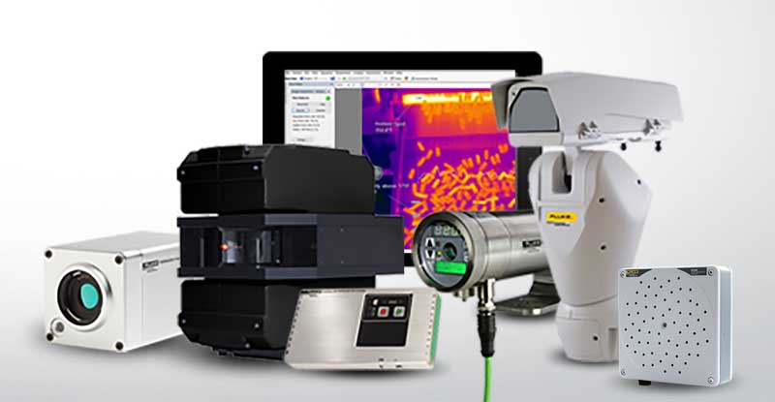
Caption: Fluke Process Instruments offers rugged temperature measurement solutions and acoustic imagers along with versatile software tools for various industry applications

SMTconnect exhibits will focus on industry-specific thermal profiling solutions for electronics manufacturing. Datapaq Reflow Trackers monitor wave and reflow soldering, vapor phase soldering, selective soldering as well as solder work at repair stations. The manufacturer offers an entire family of these temperature profiling systems for all kinds of oven setups, including miniaturized versions. The portfolio comprises various data loggers, thermal barriers, thermocouples and sensor holding frames. The accompanying software visualizes temperature profiles and supports troubleshooting, quality assurance and trend analysis; functions include maximum temperature, maximum slopes, contact time, and line speed. Users do not even have to wait for the profiler to exit the oven to visualize and analyze the data: an integrated radio transmitter optionally provides real-time data from within the process. All process and system data can also be communicated to factory-monitoring systems via the OPC interface.

Fluke Process Instruments booth numbers:
SENSOR+TEST #1-655
SMTconnect #4-145

Image/s: | fluke_process_instruments_w_sv600 | Characters: | 2421
File name: | 202204022_pm_sensor--smt_tradeshows_en | Date: | 05-05-2022
About Fluke Process Instruments
Fluke Process Instruments designs, manufactures, and markets a complete line of infrared temperature measurement and profiling solutions for industrial, maintenance, and quality control applications. Distributed worldwide under the Raytek, Ircon, and Datapaq brands, the products reflect the combined experience of over 150 years in manufacturing the world’s finest temperature measurement tools and devices.
About Fluke
Founded in 1948, Fluke Corporation is the world leader in compact, professional electronic test tools. Fluke customers are technicians, engineers, electricians, and metrologists who install, troubleshoot, and manage industrial, electrical, and electronic equipment and calibration processes.
Contact:  Fluke Process Instruments GmbH  Blankenburger Str. 135  13127 Berlin  Germany  Phone: +49 . 30 . 478 008-0  Email: marketing@flukeprocessinstruments.de  Internet: www.flukeprocessinstruments.com |  | gii die Presse-Agentur GmbH  Immanuelkirchstr. 12  10405 Berlin  Germany  Phone: +49 . 30 . 538 9650  Email: info@gii.de  Internet: www.gii.de

