Press Release

Metal detection in a tight spot: Temperature-change-resistant IGMF 202 GSP proximity switch with M8 thread

The IGMF 202 GSP inductive proximity switch from German manufacturer EGE is an excellent fit for demanding applications with limited installation space and ambient temperatures between -5 °C and 120 °C. Due to its slim stainless-steel housing with a male M8 thread, the IGMF 202 GSP can also be mounted in places for which conventional models are too large. The flush design version of the temperature-change-resistant proximity switch features a sensing distance of 2 mm for ST 37 steel. A special plastic light element at the cable outlet visually signals object detection with a yellow light. Thanks to its waterproof housing, the proximity switch qualifies for car washes and other applications with regular cleaning. The sealing concept is also suitable for use in oil-laden environments. The sensor is operated with a DC voltage between 10 V and 30 V. EGE supplies it with a two-meter FEP cable by default.

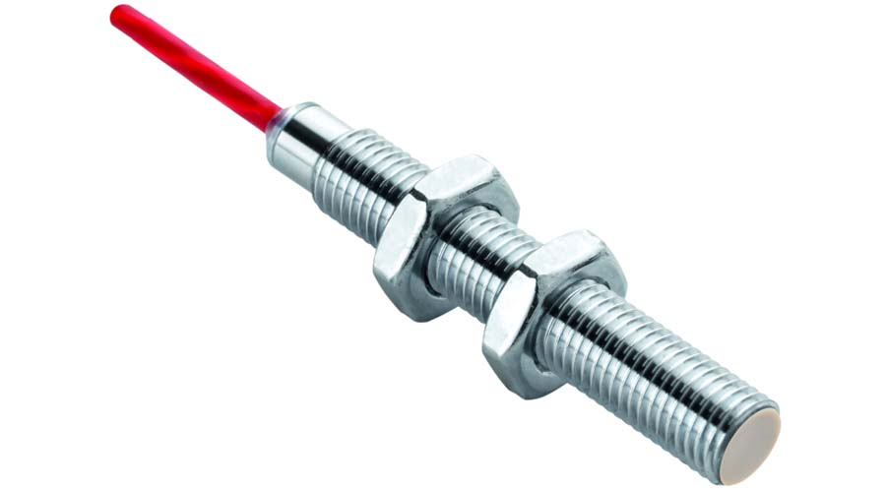
Caption: The IGMF 202 GSP inductive proximity switch is waterproof and a slim fit, and withstands temperature changes without problems

Image/s: | IGMF_202_GSP | Characters: | 912
File name: | 202205033_pm_igmf_202_gsp_proximity_en | Date: | 11-08-2022
About EGE
EGE-Elektronik Spezial-Sensoren GmbH has been developing and manufacturing special purpose sensors for automation applications since 1976. The company serves leading international producers from a wide range of industries. Its product portfolio includes flow controllers, infrared, opto and ultrasonic sensors, capacitive proximity switches, light barriers and inductive proximity switches. EGE also provides sensors for highly sensitive applications, e.g. hazardous areas. The development department's highly qualified staff cooperates closely with all customers, ensuring continuous product updates and enhancement. A total of 130 employees, including 20 engineers and technicians, generate gross sales of approx. 19.5 million Euros worldwide.
Contact:  EGE-Elektronik Spezial-Sensoren GmbH  Sven-Eric Hiss  Ravensberg 34  24214 Gettorf  Germany  Phone: +49 . 4346 . 4158-0  Email: info@ege-elektronik.com  Internet: www.ege-elektronik.com |  | gii die Presse-Agentur GmbH  Immanuelkirchstr. 12  10405 Berlin  Germany  Phone: +49 . 30 . 538 9650  Email: info@gii.de  Internet: www.gii.de

