Press Release

Hannover Messe:
New acoustic imager for fixed and mobile monitoring

At the 2022 Hannover Messe, Fluke Process Instruments (Stand #8-D34) will present its new SV600 Fixed Acoustic Imager, which enables users to detect, locate and track air or gas leaks before they become costly problems. Using an array of sophisticated sound sensors, a camera and Fluke’s powerful SoundMap technology, SV600 visualizes sounds for asset monitoring, troubleshooting and quality inspection. It easily integrates with factory systems and enables 24/7 monitoring of compressors, pumps, pipes and other equipment with user-defined alarms. Remote evaluation options help minimize operator intervention, thus improving factory safety. Notably, the SV600 acoustic imager has already been integrated, as a payload, in Boston Dynamics’ agile robot Spot for autonomous and remote-controlled surveillance in difficult-to-access or potentially unsafe environments.
More information: https://www.flukeprocessinstruments.com/en-us/products/sv600-fixed-acoustic-imager

Fluke Process Instruments at Hannover Messe
Hanover, Germany, 30 May – 2 June 2022
Hall 8, Stand D34

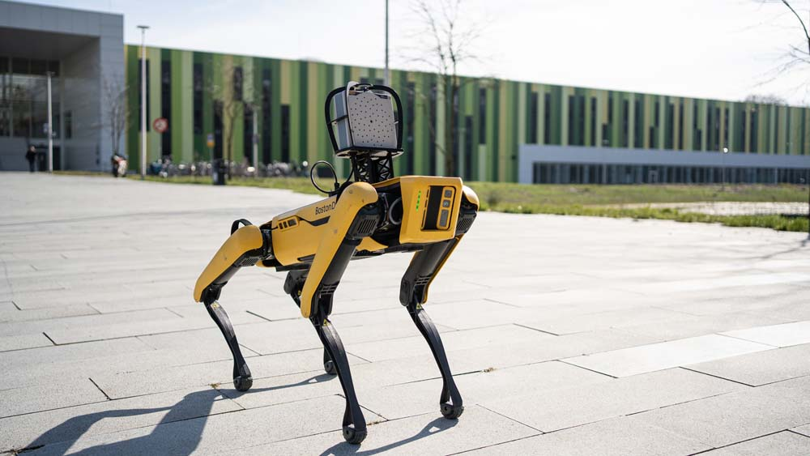
Caption: The SV600 Fixed Acoustic Imager for gas leak detection is also available as a payload for the agile robot Spot

Image/s: | sv600_mounted_on_spot_at_bic | Characters: | 866
File name: | 202205035_pm_sv600_hannover_messe_en | Date: | 05-30-2022
About Fluke Process Instruments
Fluke Process Instruments designs, manufactures, and markets a complete line of infrared temperature measurement and profiling solutions for industrial, maintenance, and quality control applications. Distributed worldwide under the Raytek, Ircon, and Datapaq brands, the products reflect the combined experience of over 150 years in manufacturing the world’s finest temperature measurement tools and devices.
About Fluke
Founded in 1948, Fluke Corporation is the world leader in compact, professional electronic test tools. Fluke customers are technicians, engineers, electricians, and metrologists who install, troubleshoot, and manage industrial, electrical, and electronic equipment and calibration processes.
Contact:  Fluke Process Instruments GmbH  Blankenburger Str. 135  13127 Berlin  Germany  Phone: +49 . 30 . 478 008-0  Email: marketing@flukeprocessinstruments.de  Internet: www.flukeprocessinstruments.com |  | gii die Presse-Agentur GmbH  Immanuelkirchstr. 12  10405 Berlin  Germany  Phone: +49 . 30 . 538 9650  Email: info@gii.de  Internet: www.gii.de

