Press Release

KDSI-SR modular cable entry installed from the outside

Conta-Clip introduces the new, inverse and modular KDSI-SR cable entry system for reliable sealing, maximum flexibility and time savings feed-through for cables with and without plugs. The system is designed for installation from the outside of a control cabinet, enclosure or machine. Part of the popular KDS Click cable management range, the KDSI-SR system, too, allows for comfortable, flexible reconfiguration of existing installations at any point in time. The components can be easily removed, exchanged and reassembled. The clever system concept for the separable insertion of individual sealing elements facilitates customized cable management – since cables with plugs do not have to be disassembled and reconnected for retrofits or servicing, the manufacturer's warranty is retained. The KDSI-SR system is based on the proven modular design and simple assembly concept of the KDS program. It merely features an inverse tapered design of the screw-on frame’s opening and includes an additional two-part cover with TPE seals in three levels. This ensures an absolutely tight fit of the sealing elements, which are available for one, two or four cables or as blanking plugs. The sealing elements with serrated edges and a tapered design provide IP66 ingress protection and reliable static strain relief in compliance to DIN EN 62444. They also allow for high packing density in comparison to cable glands. The halogen- and silicone-free KDSI-SR cable entry system is suitable for a wide range of requirements and ambient temperatures from -40 °C to 120 °C. KDSI-SR frames are available for 4, 6, 8 or 10 sealing elements in various configurations to match the number and diameters of cables.

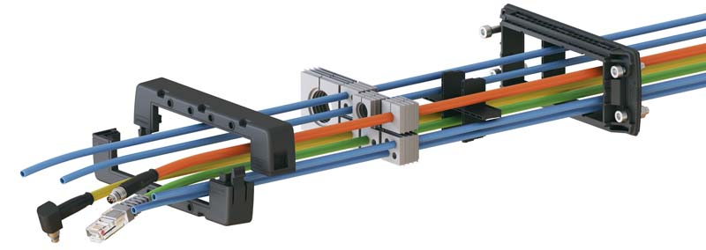
Caption 1: Exploded view of the KDSI-SR cable entry system with frame, sealing elements and cables

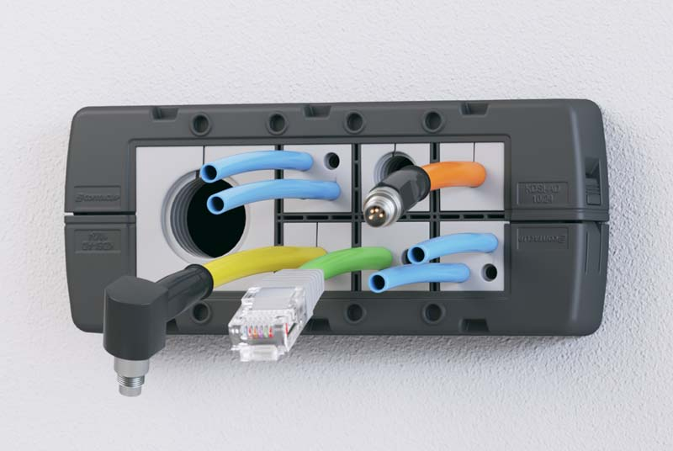
Caption 2: Modular KDSI-SR cable entry in a finished control cabinet installation

Image/s: | KDSI_explosion_mit_kabel  KDSI_installiert | Characters: | 1698
File name: | 202205037_pm_kdsi-sr_inverse_cable_entry_en | Date: | 05-31-2022
About CONTA-CLIP
CONTA-CLIP is one of Europe’s leading manufacturers of electrical and electronic connection elements and cable management solutions. Based in Hövelhof, Germany, the medium-sized, family-run company has been producing electric and electronic connection systems for the process and automation industries since 1978. CONTA-CLIP supplies all industry sectors, focusing on railroad industries, shipbuilding, building automation, conveyor technology, machine and plant engineering and construction, instrumentation and control technology, control panel manufacturing, transformer manufacturing, and environmental technology. The company consists of many specialized branches: CONTA-CONNECT for electric connection technology, CONTA-CABLE for cable management systems, CONTA-ELECTRONICS for electronics and CONTA-CON for PCB edge connectors. Additionally, CONTA-CLIP provides services such as customizing housings and mounting rails, labeling and supplying user-specific electronic components.
Contact:  CONTA-CLIP  Verbindungstechnik GmbH  Franziska Klein  Otto-Hahn-Str. 7  33161 Hövelhof  Germany  Phone: +49 . 5257 . 9833 - 173  Email: franziska.klein@conta-clip.de  Internet: www.conta-clip.com |  | gii die Presse-Agentur GmbH  Immanuelkirchstr. 12  10405 Berlin  Germany  Phone: +49 . 30 . 538 965 - 0  Email: info@gii.de  Internet: www.gii.de

