Press Release

Push-in two-level terminal blocks:
Compact, space-saving for 4-mm² wires

CONTA-CLIP expands its range of PRK push-in terminal blocks, adding the space-saving two-tier PRKD 4 and PRKD 4/3A for 4-mm² wires. The unique and compact design of the PRKD 4/3A features three inputs on each level for applications with even higher packing densities. Like all PRK terminals, the two-level versions feature cross connection channels on each level for flexible potential distribution and 2.3-mm test taps for easy measurement of all potentials. Via push-in technology, users can very easily and quickly connect rigid wires and wires with end ferrules without tools. For a quick release of inserted wires, the terminals feature a pusher that requires only slight pressure and no special tools, yet provides high contact force through the spring. The housing for the orange pushers and the wire inlets have been clearly separated from each other so as to give users the correct conductor clamping insert points 100% of the time. CONTA-CLIP is continuously expanding the PRK range, which currently includes PRKD two-level terminal blocks for 2.5-mm² and 4-mm² wire cross sections in simple feed-through and PE terminals for two, three and four wires, in four nominal cross section ranges between 1.5 mm² and 6 mm².

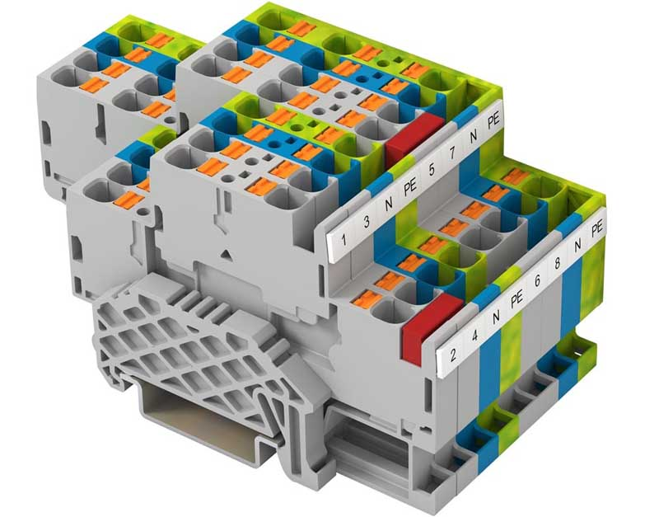
Caption: The PRKD 4 two-level terminal for 4-mm² wires and the PRKD 4/3A terminal with three wire entry points on each level allow for high packing density

Image/s: | PRKD4_Klemmleiste | Characters: | 1226
File name: | 202205038_pm_prkd_4_2-level_terminals_en | Date: | 05-24-2022
About CONTA-CLIP
CONTA-CLIP is one of Europe’s leading manufacturers of electrical and electronic connection elements and cable management solutions. Based in Hövelhof, Germany, the medium-sized, family-run company has been producing electric and electronic connection systems for the process and automation industries since 1978. CONTA-CLIP supplies all industry sectors, focusing on railroad industries, shipbuilding, building automation, conveyor technology, machine and plant engineering and construction, instrumentation and control technology, control panel manufacturing, transformer manufacturing, and environmental technology. The company consists of many specialized branches: CONTA-CONNECT for electric connection technology, CONTA-CABLE for cable management systems, CONTA-ELECTRONICS for electronics and CONTA-CON for PCB edge connectors. Additionally, CONTA-CLIP provides services such as customizing housings and mounting rails, labeling and supplying user-specific electronic components.
Contact:  CONTA-CLIP  Verbindungstechnik GmbH  Franziska Klein  Otto-Hahn-Str. 7  33161 Hövelhof  Germany  Phone: +49 . 5257 . 9833 - 173  Email: franziska.klein@conta-clip.de  Internet: www.conta-clip.com |  | gii die Presse-Agentur GmbH  Immanuelkirchstr. 12  10405 Berlin  Germany  Phone: +49 . 30 . 538 965 - 0  Email: info@gii.de  Internet: www.gii.de

