Press Release

Hygienic FDA material compliant IP66 cable entry plates for up to 32 conductors

CONTA-CLIP expands its range of KES cable entry plates, adding eight new versions made of certified food-grade material for different cable diameters and numbers of entry points. Like the existing KES solutions, the hygienic variants from the new KES-GB-FDA series enable fast and particularly space-saving routing of up to 32 non-assembled cables into control cabinets or machine housings. The plates, manufactured from a robust polyamide frame injected with elastomer, include snap-in latches for easy mounting. They are first inserted into a 36 mm x 112 mm opening from the outside of the housing and then fixed from the inside with screws. After piercing the outer membrane at marked insertion points, the cables can be easily pushed through. Conically shaped and TPE-molded sleeves on the back of the plate ensure reliable IP66 sealing and strain relief. The FDA-compliant elastomer used for the new KES-GB-FDA series meets the hygienic requirements for food approval according to 1935/2004/EC and (EU) 10/2011. The cable entry plates furthermore feature smooth surfaces, rounded corners and ECOLAB-certified material resistance to industrial cleaning agents to meet all hygiene requirements for use in the food or pharmaceutical industries.

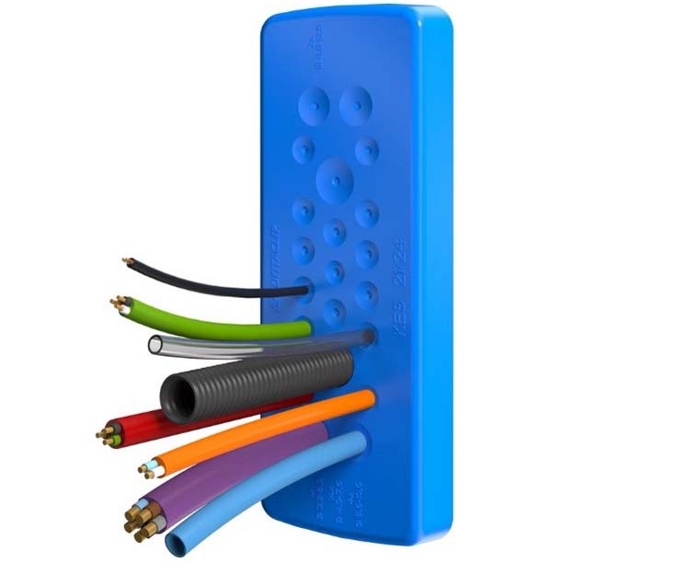
Caption: Hygienic cable entry plate from CONTA-CLIP’s new KES-GB-FDA series

Image/s: | KES-GB-FDA-1 | Characters: | 1246
File name: | 202205039_pm_kes-gb-fda_hygienic_cable_entries_en | Date: | 06-08-2022
About CONTA-CLIP
CONTA-CLIP is one of Europe’s leading manufacturers of electrical and electronic connection elements and cable management solutions. Based in Hövelhof, Germany, the medium-sized, family-run company has been producing electric and electronic connection systems for the process and automation industries since 1978. CONTA-CLIP supplies all industry sectors, focusing on railroad industries, shipbuilding, building automation, conveyor technology, machine and plant engineering and construction, instrumentation and control technology, control panel manufacturing, transformer manufacturing, and environmental technology. The company consists of many specialized branches: CONTA-CONNECT for electric connection technology, CONTA-CABLE for cable management systems, CONTA-ELECTRONICS for electronics and CONTA-CON for PCB edge connectors. Additionally, CONTA-CLIP provides services such as customizing housings and mounting rails, labeling and supplying user-specific electronic components.
Contact:  CONTA-CLIP  Verbindungstechnik GmbH  Franziska Klein  Otto-Hahn-Str. 7  33161 Hövelhof  Germany  Phone: +49 . 5257 . 9833 - 173  Email: franziska.klein@conta-clip.de  Internet: www.conta-clip.com |  | gii die Presse-Agentur GmbH  Immanuelkirchstr. 12  10405 Berlin  Germany  Phone: +49 . 30 . 538 965 - 0  Email: info@gii.de  Internet: www.gii.de

