Press Release

Slim GSM retrofit module for SMS fault messaging

Many waterworks stations and agriculture applications use compact controllers for pump or ventilation systems, which are often installed in hard-to-reach or remote places. Inspection and maintenance is not feasible for these off-grid controllers and therefore can raise considerable personnel costs. For such scenarios, Germany-based connection technology specialist CONTA-CLIP now offers a particularly economical and easy-to-retrofit solution: the GSM-TMM modem converts all messages from the controller's fault output to text messages and automatically sends them to up to five recipients. The GSM-TMM module uses the mobile communications standards LTE-M or NB-IoT, ensuring cost-efficient and energy-saving operation. The compact device in a housing measuring only 40 mm x 65 mm x 110 mm is suitable for all controllers with a live interference output and is ready for use in just a few easy steps. For easy parameterization, the modem is connected via USB to a PC running at least Windows 10. During this process, the GSM-TMM does not require an extra power supply. Once a SIM card has been inserted, the modem and controller fault outputs can be powered via a 230 V AC, 12 V DC or 24 V AC/DC supply connected to the modem’s external screw terminals. The modem features a red/green LED on its front, which, through permanent or flashing lights, indicates operating states, text message dispatch, configuration errors and potential reception problems.

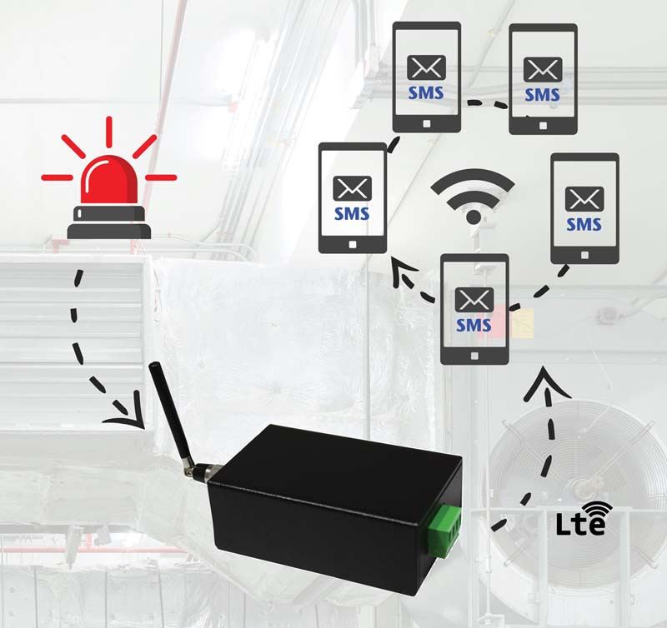
Caption: CONTA-CLIP’s new GSM-TMM modem is designed for reliable and economical fault messaging via text in remote and hard-to-reach applications

Image/s: | GSM_TMM_Anwendung | Characters: | 1456
File name: | 202205042_pm_gsm-tmm_modem_en | Date: | 07-26-2022
About CONTA-CLIP
CONTA-CLIP is one of Europe’s leading manufacturers of electrical and electronic connection elements and cable management solutions. Based in Hövelhof, Germany, the medium-sized, family-run company has been producing electric and electronic connection systems for the process and automation industries since 1978. CONTA-CLIP supplies all industry sectors, focusing on railroad industries, shipbuilding, building automation, conveyor technology, machine and plant engineering and construction, instrumentation and control technology, control panel manufacturing, transformer manufacturing, and environmental technology. The company consists of many specialized branches: CONTA-CONNECT for electric connection technology, CONTA-CABLE for cable management systems, CONTA-ELECTRONICS for electronics and CONTA-CON for PCB edge connectors. Additionally, CONTA-CLIP provides services such as customizing housings and mounting rails, labeling and supplying user-specific electronic components.
Contact:  CONTA-CLIP  Verbindungstechnik GmbH  Franziska Klein  Otto-Hahn-Str. 7  33161 Hövelhof  Germany  Phone: +49 . 5257 . 9833 - 173  Email: franziska.klein@conta-clip.de  Internet: www.conta-clip.com |  | gii die Presse-Agentur GmbH  Immanuelkirchstr. 12  10405 Berlin  Germany  Phone: +49 . 30 . 538 965 - 0  Email: info@gii.de  Internet: www.gii.de

