Press Release

Proven connection technology for electric vehicle charging stations

The booming electric vehicle sector has created a huge surge in the demand for charging stations. As a result, the number of suppliers who need reliable connection technology for their products has multiplied within a few years. CONTA-CLIP supplies manufacturers of wallboxes and other charging stations with a large range of connection terminals for communication and power supplies, as well as relay modules and robust cable management systems. Solutions include, for example, the SRK terminal block series, which offers safe and quick screw connection for rigid and flexible wires with and without wire-end ferrules. HSKG-series high-current bolt terminals are used for the safe transmission of rated currents and voltages up to 520 A and 1000 V respectively. The latest generation of bolt terminals with threaded bolts in five sizes from M6 to M16 covers wire cross sections from 6 mm² to 300 mm². Based in Germany, CONTA-CLIP connection technology specialists also offer versatile proven wiring solutions for printed circuit boards. For instance, PBK-type PCB terminals with two to 24 poles feature a push-in connection design for time-saving and tool-free insertion of solid wires or fine wires with wire-end ferrules directly into the contact point. The space-saving relay coupler system Plug-Relay-Compact (PRC) fulfils any relay needs and can be mounted in narrow and limited-space locations due to its compact terminal block format, extreme robustness and high versatility. CONTA-CLIP also offers manufacturers of electric vehicle charging stations a comprehensive and innovative portfolio of IP66-rated KDS cable entry systems for assembled and unassembled conductors: the KDS-R series of modular feed-through systems for metric cutouts from M20 to M63 enable flexible, tool-free configuration for different cable or conduit diameters. Designed for particularly easy installation, it minimizes the effort involved in replacing cables for retrofits or servicing. As a customer-oriented company, CONTA-CLIP provides direct support, custom-tailored solutions and product adaptations on request.

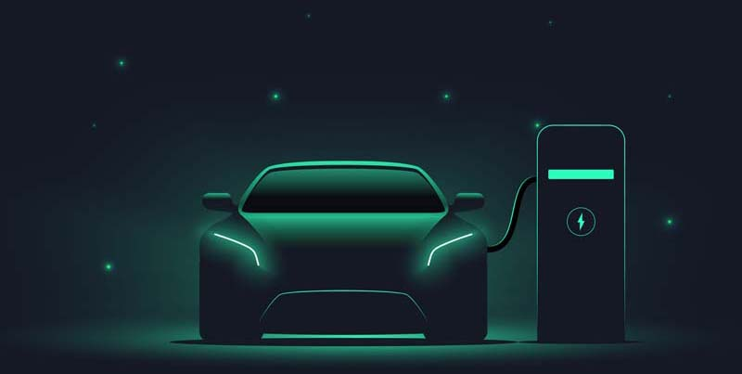
Caption: CONTA-CLIP provides a wide range of connection components for wallboxes and other charging stations for electric vehicles

Image/s: | E-Charging | Characters: | 2102
File name: | 202205043_pm_e-charging_connectivity_en | Date: | 08-31-2022
About CONTA-CLIP
CONTA-CLIP is one of Europe’s leading manufacturers of electrical and electronic connection elements and cable management solutions. Based in Hövelhof, Germany, the medium-sized, family-run company has been producing electric and electronic connection systems for the process and automation industries since 1978. CONTA-CLIP supplies all industry sectors, focusing on railroad industries, shipbuilding, building automation, conveyor technology, machine and plant engineering and construction, instrumentation and control technology, control panel manufacturing, transformer manufacturing, and environmental technology. The company consists of many specialized branches: CONTA-CONNECT for electric connection technology, CONTA-CABLE for cable management systems, CONTA-ELECTRONICS for electronics and CONTA-CON for PCB edge connectors. Additionally, CONTA-CLIP provides services such as customizing housings and mounting rails, labeling and supplying user-specific electronic components.
Contact:  CONTA-CLIP  Verbindungstechnik GmbH  Franziska Klein  Otto-Hahn-Str. 7  33161 Hövelhof  Germany  Phone: +49 . 5257 . 9833 - 173  Email: franziska.klein@conta-clip.de  Internet: www.conta-clip.com |  | gii die Presse-Agentur GmbH  Immanuelkirchstr. 12  10405 Berlin  Germany  Phone: +49 . 30 . 538 965 - 0  Email: info@gii.de  Internet: www.gii.de

