Press Release

Stereo camera for embedded vision

Vision Components launches a new type of embedded vision system for 3D and dual-camera applications. The VC Stereo Cam can be flexibly configured for a wide range of OEM projects. It is based on the powerful VC Power SoM image processing module with an onboard FPGA, which preprocesses large data volumes in real time and transfers the results in the MIPI data stream to a higher-level CPU. This allows users the free choice of their processor platform. The FPGA is open for customer programming. Vision Components’ extensive groundwork for stereo image processing with synchronized triggering and optional disparity matching saves users a lot of development effort. The manufacturer also supports project development, offering ready-made FPGA designs for applications like object recognition and specific tasks like 3D point cloud generation. The FPGA with its 120,000 logic cells handles even such complex calculations in real time. As a result, sophisticated 3D applications such as exact people counting and volume determinations are possible.

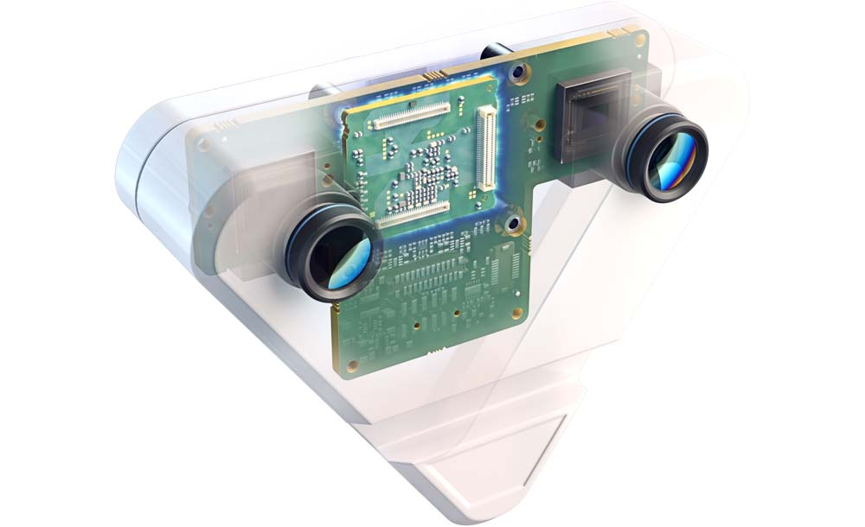
Caption: The VC Stereo Cam with prepared FPGA functions for 3D imaging and MIPI interfaces for connection to various processor platforms allows vision OEMs to accelerate the time to market

As with all its products, Vision Components ensures industrial suitability and long-term availability. Customers can freely select the VC MIPI camera modules. The prototype VC Stereo Cam for 3D vision integrates two Sony Pregius IMX296 global shutter image sensors. Alternatively, it is also possible to integrate different sensors, for example for day/night shots or for parallel shots in color and monochrome or in the visible and SWIR spectrum. Vision Components offers a huge range of MIPI modules. At the embedded world exhibition in Nuremberg, Germany, Vision Components will present the VC Stereo Cam along with brand-new MIPI camera modules and components for fast and efficient embedded vision designs.
Vision Components at embedded world
Nuremberg, Germany, 21 – 23 June 2022
Hall 2, Stand 450

Image/s: | vc_stereo_cam_case_ghosting | Characters: | 1758
File name: | 202205044_pm_vc_stereo_cam_en | Date: | 05-31-2022
About Vision Components
Vision Components is a leading international manufacturer of embedded vision systems. The freely programmable cameras with powerful onboard CPUs perform image processing tasks on their own without the need for an additional computer. Vision Components offers OEMs versatile Linux-based embedded systems for 2D and 3D image processing, supplied as board cameras or in protective casings. These are complemented by a growing range of ultracompact MIPI camera boards, which connect to a variety of different CPU boards. In addition, Vision Components offers software libraries and develops customized solutions on request. The team of experts can draw on extensive knowledge and over 20 years of experience with imaging applications. The company based in Ettlingen in southwestern Germany was founded in 1996 by Michael Engel, the inventor of the first industrial-grade intelligent camera. More world premieres followed, including the world's first intelligent vision sensors and the first-ever embedded 3D laser profiler. Today, Vision Components has sales offices in the United States and Japan and works with local partners in over 25 countries to provide consistent customer focus and readily available expertise throughout the world.
Contact:  Vision Components GmbH  Jan-Erik Schmitt  Ottostr. 2  76275 Ettlingen  Germany  Phone: +49 . 7243 . 21670  Email: schmitt@vision-components.com  Internet: www.vision-components.com |  | gii die Presse-Agentur GmbH  Immanuelkirchstr. 12  10405 Berlin  Germany  Phone: +49 . 30 . 538 9650  Email: info@gii.de  Internet: www.gii.de

