Press Release

IO-Link converter from EGE:
Digital retrofit for analog sensor signals

Launching the new multifunctional IO-Link converter IOL-KONV-UIS-01, EGE presents a compact and simple solution for noise-free digital signal transmission from conventional sensors via IO-Link. Depending on its configuration, the converter registers up to two analog values (0...10 V, 4...20 mA) or switching signals from the connected sensor, converts them into digital signals and transmits them to an IO-Link primary device. In addition to the digital output for process data transmission, the device has a second, analog output for programmable current or switching signals. All conventional sensors from EGE and other manufacturers can be connected to the converter, regardless of operating principles and measured values. The IO-Link converter offers additional monitoring functions. If the power consumption or operating voltage of the connected sensor deviate from recorded setpoints, for instance due to corrosion, the device sends an error message to the controller as an IO-Link event. To protect its own electronics, the converter features temperature monitoring, short-circuit detection and an adjustable shutdown function in case of overload. A front-end multicolor LED clearly shows the operating status. M12 connectors for sensors and IO-Link primary devices eliminate any cabling effort. The IP67-rated converter housing features lugs for flexible mounting near the sensor in all installation conditions. The converter is parameterized according to IO-Link Device Description V1.1 using an engineering tool connected via the IO-Link interface.

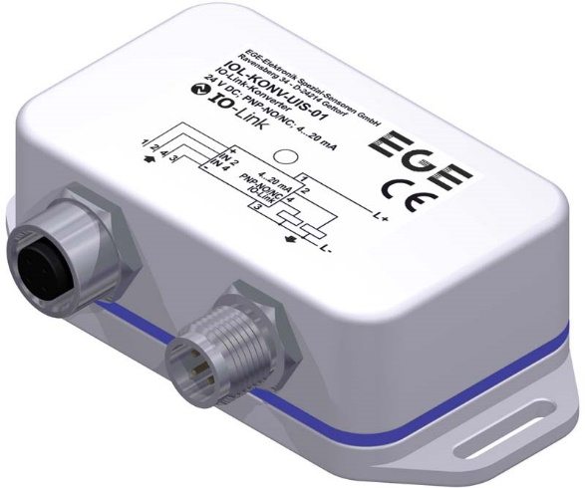
Bild: The new multifunctional IO-Link converter IOL-KONV-UIS-01 connects to all EGE sensors

Image/s: | IOL-KONV-UIS-01_3D | Characters: | 1560
File name: | 202206007_pm_io-link_converter_en | Date: | 06-08-2022
About EGE
EGE-Elektronik Spezial-Sensoren GmbH has been developing and manufacturing special purpose sensors for automation applications since 1976. The company serves leading international producers from a wide range of industries. Its product portfolio includes flow controllers, infrared, opto and ultrasonic sensors, capacitive proximity switches, light barriers and inductive proximity switches. EGE also provides sensors for highly sensitive applications, e.g. hazardous areas. The development department's highly qualified staff cooperates closely with all customers, ensuring continuous product updates and enhancement. A total of 130 employees, including 20 engineers and technicians, generate gross sales of approx. 19.5 million Euros worldwide.
Contact:  EGE-Elektronik Spezial-Sensoren GmbH  Sven-Eric Hiss  Ravensberg 34  24214 Gettorf  Germany  Phone: +49 . 4346 . 4158-0  Email: info@ege-elektronik.com  Internet: www.ege-elektronik.com |  | gii die Presse-Agentur GmbH  Immanuelkirchstr. 12  10405 Berlin  Germany  Phone: +49 . 30 . 538 9650  Email: info@gii.de  Internet: www.gii.de

