Press Release

IECEx-approved SZAb evaluation devices for flow monitors

SZAb evaluation devices from EGE for ATEX-certified ST and STS flow monitors are now available with an IECEx approval. These devices feed sensors installed in hazardous environments. They have an intrinsically safe circuit, galvanically isolated from the signal output and mains supply and are mounted in a control cabinet outside areas with potentially explosive atmospheres. For application-specific signaling, the evaluation devices are available with relay or analog 4...20 mA outputs. The relay output versions allow users to set switch-off delays of up to 25 seconds. Limit values for all models are simply set via a potentiometer on the front of the device. A multi-color LED line indicates the flow tendency. A red LED light indicates that the default limit value is not reached and the switching output is not active. A yellow LED indicates that the limit value has been reached and the output is switched. In addition, four green LEDs show by how much, relatively, the limit value is being exceeded. To avoid unnoticed defects, the evaluation devices feature cable breakage and short-circuit monitoring functions. The analog output version requires a 24 V DC power supply. Models with a relay output are also available for 230 V AC or 115 V AC operation.

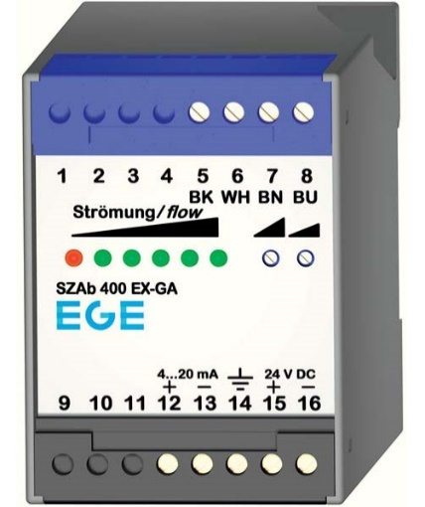
Bild: EGE now provides the SZAb evaluation device for series ST and STS ATEX-certified flow monitors with an IECEx-approval

Image/s: | SZAb_400_EX-GA |  | Characters: | 1264
File name: | 202206011_pm_szab_eval_units_iecex_approval_en |  | Date: | 08-10-2022
About EGE
EGE-Elektronik Spezial-Sensoren GmbH has been developing and manufacturing special purpose sensors for automation applications since 1976. The company serves leading international producers from a wide range of industries. Its product portfolio includes flow controllers, infrared, opto and ultrasonic sensors, capacitive proximity switches, light barriers and inductive proximity switches. EGE also provides sensors for highly sensitive applications, e.g. hazardous areas. The development department's highly qualified staff cooperates closely with all customers, ensuring continuous product updates and enhancement. A total of 130 employees, including 20 engineers and technicians, generate gross sales of approx. 19.5 million Euros worldwide.
Contact:  EGE-Elektronik Spezial-Sensoren GmbH  Sven-Eric Hiss  Ravensberg 34  24214 Gettorf  Germany  Phone: +49 . 4346 . 4158-0  Email: info@ege-elektronik.com  Internet: www.ege-elektronik.com |  | gii die Presse-Agentur GmbH  Immanuelkirchstr. 12  10405 Berlin  Germany  Phone: +49 . 30 . 538 9650  Email: info@gii.de  Internet: www.gii.de

