Innovative cable gland solution for e-mobility applications
Easy pre-assembly of high-voltage cables

EVolution EMC is AGRO’s new cable gland for high-voltage cabling of electric commercial vehicles and mobile machines. The innovative connection system, with its “pluggable” shield contact design, facilitates quicker installation in vehicle manufacturing, with the cable glands reliably pre-assembled in just five steps. With the cable shield fully clamped between a ring and a sleeve by crimping, the protrusion of shield strands is prevented. Thanks to the decoupling of the sealing function from the shield contact, temperature- and vibration-related impacts on shielding effectiveness or current-carrying capacity are avoided. Following pre-assembly, the cable shield cannot be damaged. Furthermore, repairs can be carried out without diminishing performance because the cable shield is not affected by repeated insertion and the split sealing insert can be replaced without disconnecting the conductor. The cable glands, which are available in sizes M20 to M32, achieve a current carrying capacity of up to 195 A without overheating. The shielding effectiveness is at least 86 dB in the range from 30 MHz to 300 MHz. EVolution EMC offers protection class IP 68 or IP 6K9K, and is certified for temperatures from -40 °C to +140 °C.

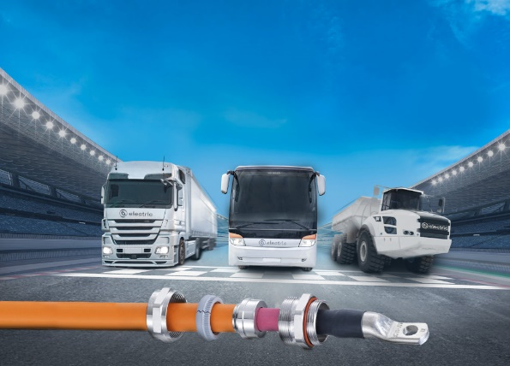
Image: The EVolution EMC cable gland – for high-voltage cables in electric or hybrid commercial vehicles

(Image source: AGRO AG)

AGRO cable glands
Progress® . Syntec® . EMC . Ex . Braided sleevings . Protective conduits . Conduit glands . E-mobility . Multiple cable entries . Accessories .

Product animation:

Image/s: | kv_emc_elektrofahrzeuge_3000.jpg | Char‘s: | 1.234
File name: | 202206013_pm_kv_emc_en.docx | Date: | 07-28-2022
About AGRO
The Swiss company AGRO AG has been developing and manufacturing high-quality solutions for cable management and electrical installation since 1953. The company is a pioneer in the field of cable glands, boasting numerous innovations and patents. It offers a comprehensive product range of more than 7,000 items to meet all industry and trade requirements, and has a certified in-house test laboratory. AGRO has a large network of expert distributors in 40 countries worldwide, and has a subsidiary in Shanghai for the Chinese market. The company, which is based in Hunzenschwil in Aargau, Switzerland, employs around 120 people and, since 2002, has been part of the KAISER GROUP, which also includes the brands KAISER GmbH & Co. KG as well as the Belgian company HELIA N.V. and ATTEMA B.V. (Netherlands).

Further information:
AGRO AG | Member of KAISER GROUP, Korbackerweg 7,
5502 Hunzenschwil, Switzerland
Tel.: +41(0)62 889 47 47; Fax: +41(0)62 889 47 50
Email: info@agro.ch; Web: www.agro.ch

