Press Release

High-power stud terminals for safe energy transmission

CONTA-CLIP’s HSKG stud terminals ensure secure connections for all energy-transmitting applications. The lineup comprises five terminal sizes for wire cross sections from 35 mm² to 300 mm². HSKG terminals can be installed as required on standard TS 35 DIN rails in accordance with EN 60715. They are suited for rated currents from 125 A to 520 A at rated voltages up to 1000 V. The terminals feature M6, M8, M10, M12, or M16 threaded studs, depending on the wire cross section. Conductors are applied to the studs with crimped cable lugs and then securely connected to the busbar with hex nuts. Each stud can hold two cable lugs. Combination one-piece washer and hex locknuts provide superior safety via conical spring force, contact strength, vibration resistance and maintenance-free connections ultimately eliminating retightening. A low voltage drop and self-extinguishing material with a V0 (UL94) flammability rating ensure maximum safety. Cross-connection rails for potential distribution are available as two or three-pole versions. Additionally, CONTA-CLIP provides accessories that facilitate installation and further safety features, for example ADH hinged covers with touch protection even while inserting a test probe and variable colors for identification. The ADH cover is easy to mount – it simply snaps into the side walls of the stud terminal as it is closed. ES 35/K/ST end stops grip both sides of the DIN rail with steel clamps, ensuring steady support for the terminal block construction. For optimal equipment identification, the stud terminals can be labeled with the CONTA-CLIP Pocket-Maxicard PMC marking system.
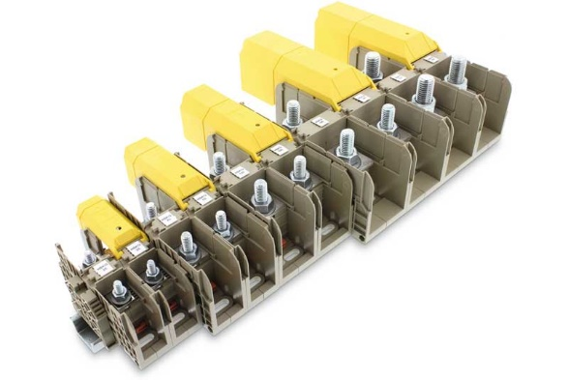
Caption: CONTA-CLIP supplies HSKG high-power stud terminals for wire cross sections from 35 mm² to 300 mm²

Image/s: | HSKG_Leiste_3 | Characters: | 1638
File name: | 202206019_pm_hskg_stud_terminals_en | Date: | 10-13-2022
About CONTA-CLIP
CONTA-CLIP is one of Europe’s leading manufacturers of electrical and electronic connection elements and cable management solutions. Based in Hövelhof, Germany, the medium-sized, family-run company has been producing electric and electronic connection systems for the process and automation industries since 1978. CONTA-CLIP supplies all industry sectors, focusing on railroad industries, shipbuilding, building automation, conveyor technology, machine and plant engineering and construction, instrumentation and control technology, control panel manufacturing, transformer manufacturing, and environmental technology. The company consists of many specialized branches: CONTA-CONNECT for electric connection technology, CONTA-CABLE for cable management systems, CONTA-ELECTRONICS for electronics and CONTA-CON for PCB edge connectors. Additionally, CONTA-CLIP provides services such as customizing housings and mounting rails, labeling and supplying user-specific electronic components.
Contact:  CONTA-CLIP  Verbindungstechnik GmbH  Franziska Klein  Otto-Hahn-Str. 7  33161 Hövelhof  Germany  Phone: +49 . 5257 . 9833 - 173  Email: franziska.klein@conta-clip.de  Internet: www.conta-clip.com |  | gii die Presse-Agentur GmbH  Immanuelkirchstr. 12  10405 Berlin  Germany  Phone: +49 . 30 . 538 965 - 0  Email: info@gii.de  Internet: www.gii.de

