Press Release

Vision Components website relaunch

Vision Components has completely redesigned its website www.vision-components.com with all information in a clear, modern design and with new navigation. All embedded vision products and services are presented in a flat menu structure. The German manufacturer has been a trendsetter and technology leader in decentralized machine vision for over 25 years and offers three distinct product groups for OEM projects: MIPI camera modules, embedded vision systems and 3D camera systems. Vision Components also supports application development for various sectors, supplying tested and proven, perfectly matched accessories – from suitable drivers for common processor boards to FPC cables, adapters and lighting. A growing tech blog on the website shares know-how from day-to-day development work. Application examples are presented in detail under the menu item References. With a view to different user groups, general pages for decision-makers and resources for developers are clearly separated, while ensuring easy access to technical data and documentation for current and discontinued product lines. The entire web offer is characterized by a modern, adaptive, fast-loading design that invites users to contact qualified staff cited on each topical page.

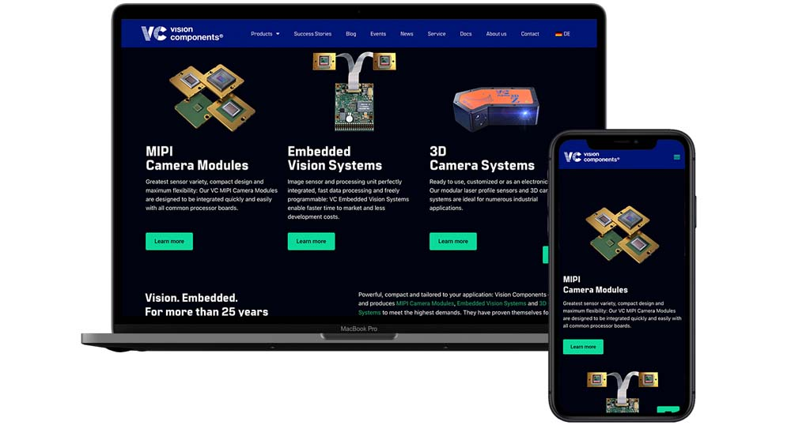
Caption: The relaunched www.vision-components.com website invites users to check out the versatile offer for embedded vision development

Image/s: | vision-components-com_en | Characters: | 1255
File name: | 202207023_pm_new_website_en | Date: | 07-14-2022
About Vision Components
Vision Components is a leading international manufacturer of embedded vision systems. The freely programmable cameras with powerful onboard CPUs perform image processing tasks on their own without the need for an additional computer. Vision Components offers OEMs versatile Linux-based embedded systems for 2D and 3D image processing, supplied as board cameras or in protective casings. These are complemented by a growing range of ultracompact MIPI camera boards, which connect to a variety of different CPU boards. In addition, Vision Components offers software libraries and develops customized solutions on request. The team of experts can draw on extensive knowledge and over 20 years of experience with imaging applications. The company based in Ettlingen in southwestern Germany was founded in 1996 by Michael Engel, the inventor of the first industrial-grade intelligent camera. More world premieres followed, including the world's first intelligent vision sensors and the first-ever embedded 3D laser profiler. Today, Vision Components has sales offices in the United States and Japan and works with local partners in over 25 countries to provide consistent customer focus and readily available expertise throughout the world.
Contact:  Vision Components GmbH  Jan-Erik Schmitt  Ottostr. 2  76275 Ettlingen  Germany  Phone: +49 . 7243 . 21670  Email: schmitt@vision-components.com  Internet: www.vision-components.com |  | gii die Presse-Agentur GmbH  Immanuelkirchstr. 12  10405 Berlin  Germany  Phone: +49 . 30 . 538 9650  Email: info@gii.de  Internet: www.gii.de

