Press Release

RACON ST: New generation of tactile switches from RAFI

RAFI’s tried-and-tested RACON 8 and RACON 12 S tactile switch series are now available in a temperature-optimized version intended for various PCB protection procedures: Thanks to the additional sealing system, the new RACON ST tactile switch series (sealed & extended temperature range) is ideal for casting, lacquering and nanocoating of correspondingly equipped PCBs. In addition, RACON ST sets itself apart from conventional switches thanks to its 35°C higher maximum operating temperature and, with a temperature resistance of -40°C to +125°C, it also meets the current standards of the automotive industry. None of the usual RACON tactility is lost due to the extended durability features. Like the existing series of key switches, the ST switches have compact dimensions of 12 mm x 12 mm or 8.4 mm x 8.4 mm and are available in SMT or THT versions. High-quality gold contacts ensure permanent switching reliability. To meet the various demands of tactile feedback, the switches are available in types for operating forces of 2.5 N to 9.7 N. For applications underneath membranes, the range of accessories includes round or square plungers in twelve lengths ranging from 1.4 mm to 7.6 mm.

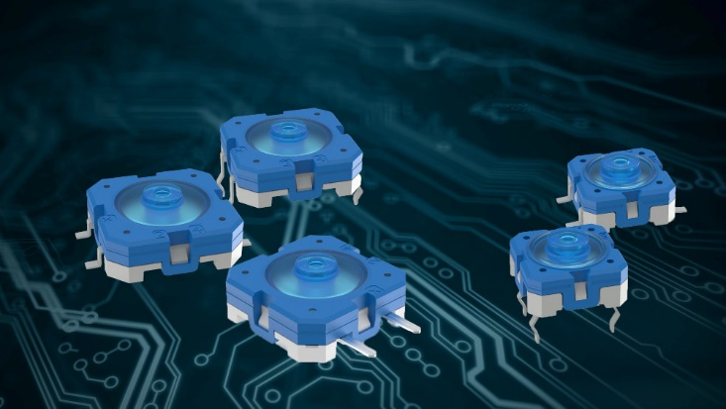
Caption: With RACON ST, RAFI has developed a series of switches that is particularly temperature-resistant and suitable for various PCB protection procedures

Image/s: | racon-st_taster_2000px | Characters: | 1.193
File name: | 202207025_pm_RACON-ST_en | Date: | 11-22-2022
About the RAFI group
Founded in 1900, RAFI today develops and produces electromechanical components and systems for human–machine interaction. The range of products includes pushbuttons, switches, touchscreens, control systems and electronic assemblies. RAFI products are employed in many industries including automation, medical technology, machine and plant engineering, road and railway vehicles, household appliances and telecommunication. The RAFI group operates internationally with more than 2,000 employees at sites in Germany, Europe, China and the USA. Its headquarters are in Berg, Germany.
Contact:  RAFI Group  Lisa Schuldt  Ravensburger Straße 128-134  88276 Berg  Germany  Phone: +49 751 89-1516  Email: llisa-marija.schuldt@rafi-group.com  Internet: www.rafi-group.com |  | gii die Presse-Agentur GmbH  Immanuelkirchstr. 12  10405 Berlin  Germany  Phone: +49 30 538 9650  Email: info@gii.de  Internet: www.gii.de

