Press Release

Highly compact three-phase power quality meter

Introducing the MAVOWATT 210, Gossen Metrawatt completes its range of portable energy and power quality meters, adding an economical and – at only 640 g – very light device. The bidirectional datalogger precisely measures all parameters relevant for ensuring the quality of the energy supply both on the power utility and consumer side. Reductions in power quality such as voltage drops, dips or interruptions and overvoltages are detected with a resolution of 1/2 cycles according to IEC 61000-4-30, and harmonics are recorded according to IEEE 519-2014/IEC 61000-4-7. The device, which has four voltage channels for direct measurement up to 600 V_{RMS} (CAT III) and four current channels, is suitable for all relevant performance parameters such as voltage, current, active, reactive and apparent power. In addition, it serves as a high-precision bidirectional four-quadrant measuring device for energy flow detection, e.g., in wind power and photovoltaic systems. Automatic detection of the type of connection and indication of connection errors via color-coded LEDs ensure safe operation at all times. The compact MAVOWATT 210 allows for up to seven hours battery-powered operation in any local or remote system. For visualization and evaluation, an integrated Ethernet interface with a web server enables real-time access to all present and previously logged measured values. Operators can create analyses and reports using the Dran-View XP PC software, which is specially adapted to the MAVOWATT 210 and included in the scope of delivery free of charge. Standard equipment furthermore includes three Rogowski coils with a measuring range up to 500 A, four voltage cables and a power supply unit. The manufacturer also offers additional current sensors.

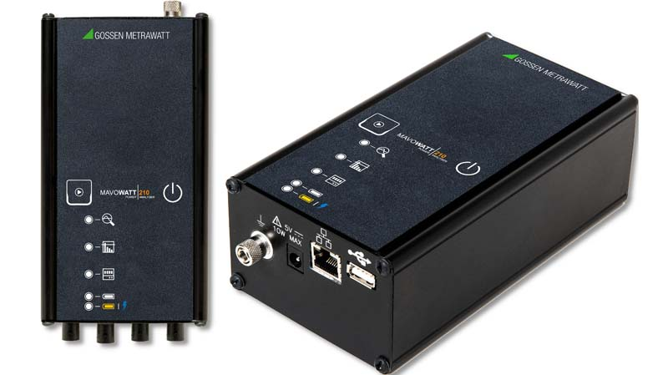
Caption 1: The compact, portable, battery-powered MAVOWATT 210 power quality meter enables cost-efficient energy and mains data logging

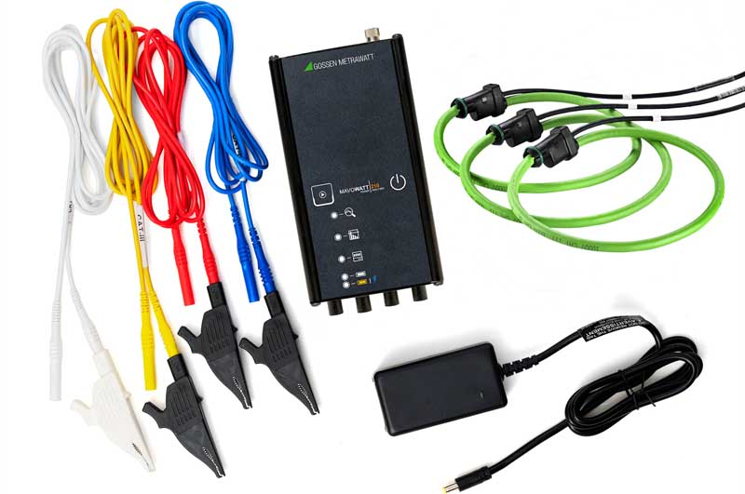
Caption 2: Gossen Metrawatt supplies the new MAVOWATT 210 with power supply, three Rogowski coils and four voltage cables by default

Image/s: | mavowatt210  mavowatt-210-set | Characters: | 1756
File name: | 202208004_pm_mavowatt_210_power_qual_meter_en | Date: | 08-02-2022
About Gossen Metrawatt
Gossen Metrawatt, one of the world’s leading suppliers of measurement systems, develops and distributes a wide range of high-quality measuring and test devices for electrical trade, various industries and the public sector.
The Gossen Metrawatt brand has been synonymous with safety and quality “Made in Germany” for decades. Its product range includes measurement and test technology for the electrical safety of plants, devices and machines as well as for the e-mobility and medical technology industries. Additional key areas of interest are power quality, battery testing technology, multimeters, calibrators, power supply technology and energy management systems. For a truly comprehensive electrical safety portfolio, Gossen Metrawatt also offers a continuously growing range of digital services and cloud services and supports its customers with a versatile training program and a wide range of after-sales services.
Gossen Metrawatt is part of the GMC Instruments Group, which also includes other specialized manufacturers for measurement and testing technology – notably, Camille Bauer Metrawatt, Dranetz, Prosys, Seaward and Rigel and Kurth Electronic. The Camille Bauer and Rigel brands add to the portfolio various transducers, display instruments and detection systems for heavy-current engineering as well as special measuring, testing and functional testing devices for the medical sector. The GMC-I Group runs its own DAkkS-certified calibration center that performs DAkkS, ISO and factory calibrations for virtually all electrical measured quantities. The GMC-I Group has development and production sites in Germany, Switzerland, England and the USA and a worldwide sales network of its own companies as well as sales partners.
Contact:  Gossen Metrawatt GmbH  Christian Widder  Head of Marketing Communication  Suedwestpark 15  90449 Nuremberg  Germany  Phone: +49 . 911 . 8602-572  Email: christian.widder@gossenmetrawatt.com  Internet: www.gossenmetrawatt.com |  | gii die Presse-Agentur GmbH  Immanuelkirchstr. 12  10405 Berlin  Germany  Tel.: +49 . 30 . 538 9650  Email: info@gii.de  Internet: www.gii.de

