Press Release

Gossen Metrawatt completes new TRMS multimeter series

Launching the METRAHIT IM TECH BT, Gossen Metrawatt completes its new generation of digital TRMS multimeters. METRAHIT IM series mains-independent universal multimeters come with a patented quick-change rechargeable battery and are the only handheld devices on the market to integrate a four-wire milliohm measuring function with up to 1 µΩ resolution. The new IM TECH BT model, which is tailored to use in industrial production and testing areas and service in the field, covers a wide range of tests. Thus, this economical solution is ideal for maintenance, service and diagnostics on electric machines and drives as well as systems from the automotive, energy and automation sectors. Milliohm measurement with an adjustable measuring current of 200 mA or 1 A makes it possible to precisely determine even minimal contact resistances in welded and rivet connections, e.g., on aircraft outer skins (Wick test) and precisely measure the equipotential bonding of hybrid and electric vehicles according to UN ECE R100 with 200 mA.

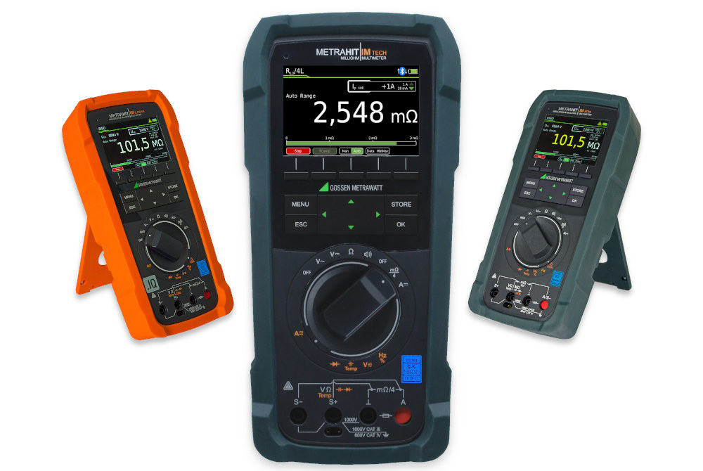
Caption: The new TRMS multimeter METRAHIT IM TECH BT with integrated milliohm measurement and a patented quick-change rechargeable battery

The DAkkS-calibrated multimeter conforms to measurement category 1000 V CAT III. Its functional scope also includes TRMS measurements for current and voltage up to 10 kHz or 100 kHz and precision temperature measurements with RTD resistance sensors and type K thermocouples. Additional functions include capacitance measurement, direct and indirect current measurement with clamp sensors, diode testing under constant current and quick continuity testing for short circuits and interruptions with acoustic signaling. Users can activate a 1-kHz low-pass filter to detect dangerous voltages, e.g., on cables with parasitic external signals. The various measuring functions can be selected easily and safely via a rotary switch. Test sequences, measurement settings and results are clearly displayed on a 3.5'' TFT color display with good legibility even in bright light. The integrated datalogger with a real-time clock saves up to 300,000 measured values, which can also be directly transmitted to the test software using the push/print function. A Bluetooth interface is integrated for data communication. The METRAHIT IM TECH BT, which provides protection against dust and splashing water according to IP52, is supplied with a protective rubber cover, hard case, lithium-ion battery, USB charger, safety measuring cables, Kelvin clips, DAkkS calibration certificate, short-form operating instructions and with an IZYTRONIQ Business starter license.

Image/s: | metrahit_im_trio_2000px.jpg | Characters: | 2477
File name: | 202208005_pm_metrahit_im_tech_bt_multimeter_en | Date: | 09-06-2022
About Gossen Metrawatt
Gossen Metrawatt, one of the world’s leading suppliers of measurement systems, develops and distributes a wide range of high-quality measuring and test devices for electrical trade, various industries and the public sector.
The Gossen Metrawatt brand has been synonymous with safety and quality “Made in Germany” for decades. Its product range includes measurement and test technology for the electrical safety of plants, devices and machines as well as for the e-mobility and medical technology industries. Additional key areas of interest are power quality, battery testing technology, multimeters, calibrators, power supply technology and energy management systems. For a truly comprehensive electrical safety portfolio, Gossen Metrawatt also offers a continuously growing range of digital services and cloud services and supports its customers with a versatile training program and a wide range of after-sales services.
Gossen Metrawatt is part of the GMC Instruments Group, which also includes other specialized manufacturers for measurement and testing technology – notably, Camille Bauer Metrawatt, Dranetz, Prosys, Seaward and Rigel and Kurth Electronic. The Camille Bauer and Rigel brands add to the portfolio various transducers, display instruments and detection systems for heavy-current engineering as well as special measuring, testing and functional testing devices for the medical sector. The GMC-I Group runs its own DAkkS-certified calibration center that performs DAkkS, ISO and factory calibrations for virtually all electrical measured quantities. The GMC-I Group has development and production sites in Germany, Switzerland, England and the USA and a worldwide sales network of its own companies as well as sales partners.
Contact:  Gossen Metrawatt GmbH  Christian Widder  Head of Marketing Communication  Suedwestpark 15  90449 Nuremberg  Germany  Phone: +49 . 911 . 8602-572  Email: christian.widder@gossenmetrawatt.com  Internet: www.gossenmetrawatt.com |  | gii die Presse-Agentur GmbH  Immanuelkirchstr. 12  10405 Berlin  Germany  Tel.: +49 . 30 . 538 9650  Email: info@gii.de  Internet: www.gii.de

