Press Release

VISION trade fair: Fast-track OEM serial development with VC embedded vision solutions

At the VISION trade fair in Stuttgart, Germany, Vision Components will premiere the miniaturized VC picoSmart 3D laser profile sensor. This versatile OEM component has been developed for fast-track design of economic, tailored 3D systems. It combines two tested and proven modules developed inhouse and matched for perfect results: the world’s smallest image processing system VC picoSmart, which is fully integrated on a 22 mm x 23.5 mm board, and a line laser module.

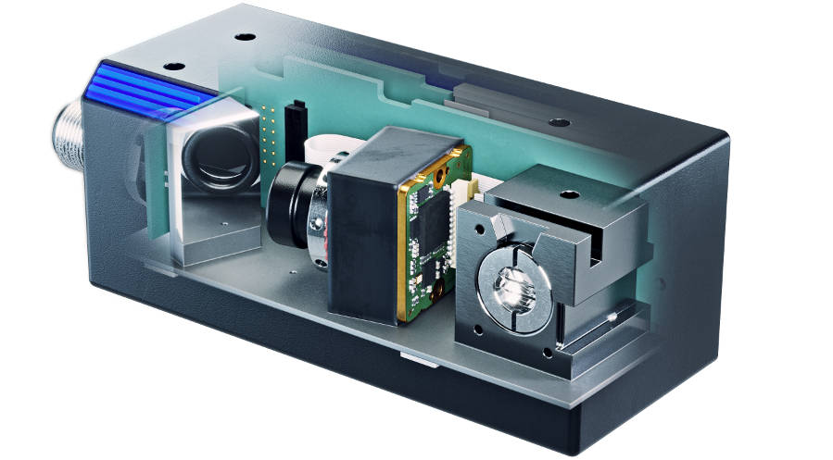
Caption: OEM components such as the miniaturized VC picoSmart 3D laser profile sensor with onboard image processing, shortly to premiere at the VISION trade fair, reduce the development effort required for new sensors and embedded vision projects

Additional trade fair highlights include the ultracompact FPGA-based image processing booster VC Power SoM with a board footprint of only 28 mm x 24 mm and, based on it, the VC Stereo Cam. The hardware accelerator executes complex image pre-processing operations in real time, for instance color space conversion, barcode identification or data fusion from stereo vision or multicamera applications. It allows vision OEMs a flexible choice of processor board and is easy to integrate in all kinds of embedded vision electronics designs. For series development, the VC Power SoM can be integrated into mainboard designs as a module or combined with an I/O board with multiple MIPI ports. Thus, vision OEMs achieve series maturity in less time and more efficiently. Not least, Vision Components will also present its huge and continuously growing portfolio of MIPI camera modules, including modules for SWIR and 3D/ToF applications.
Vision Components at VISION
Stuttgart, Germany, 4 – 6 October 2022
Hall 8, Stand C31

Image/s: | vc_picosmart_3d | Characters: | 1399
File name: | 202208016_pm_vision_tradeshow_en | Date: | 08-17-2022
About Vision Components
Vision Components is a leading international manufacturer of embedded vision systems. The freely programmable cameras with powerful onboard CPUs perform image processing tasks on their own without the need for an additional computer. Vision Components offers OEMs versatile Linux-based embedded systems for 2D and 3D image processing, supplied as board cameras or in protective casings. These are complemented by a growing range of ultracompact MIPI camera boards, which connect to a variety of different CPU boards. In addition, Vision Components offers software libraries and develops customized solutions on request. The team of experts can draw on extensive knowledge and over 20 years of experience with imaging applications. The company based in Ettlingen in southwestern Germany was founded in 1996 by Michael Engel, the inventor of the first industrial-grade intelligent camera. More world premieres followed, including the world's first intelligent vision sensors and the first-ever embedded 3D laser profiler. Today, Vision Components has sales offices in the United States and Japan and works with local partners in over 25 countries to provide consistent customer focus and readily available expertise throughout the world.
Contact:  Vision Components GmbH  Jan-Erik Schmitt  Ottostr. 2  76275 Ettlingen  Germany  Phone: +49 . 7243 . 21670  Email: schmitt@vision-components.com  Internet: www.vision-components.com |  | gii die Presse-Agentur GmbH  Immanuelkirchstr. 12  10405 Berlin  Germany  Phone: +49 . 30 . 538 9650  Email: info@gii.de  Internet: www.gii.de

