Press Release

Cement mill motor in economic 1-for-3 design

Menzel Elektromotoren supports customers' economical spare parts management by configuring large industrial motors as common parts. The German, family-run company has built a replacement motor for a cement plant in Pakistan that can drive any one of three applications: the raw mill, another cement mill or a fan. The motors originally installed differ in various features. But most importantly, the available installation space is extremely limited. Therefore, a Menzel engineer visited the site to take all the measurements. The solution was a compact slip ring motor in frame size 710 with the cooling system tailored to fit around a steel girder in the cement plant. To accommodate the existing couplings in two different sizes, Menzel designed the replacement motor with two shaft ends with different diameters. The motor output is configured to ensure efficient continuous operation in each of the three applications. The machine has a rated output of 4600 kW and a rated voltage of 6300 V. It complies with protection class IP55. At the customer's request, it was designed in cooling type IC 666, i.e., with permanent external ventilation of the inner and outer cooling circuit. Before delivery, Menzel ran a load test in its inhouse test field. Although the customer could not be there in person, they attended the load test live via video streaming, which Menzel offers as a standard service.
Additional reference projects: https://www.menzel-motors.com/mill-drive/

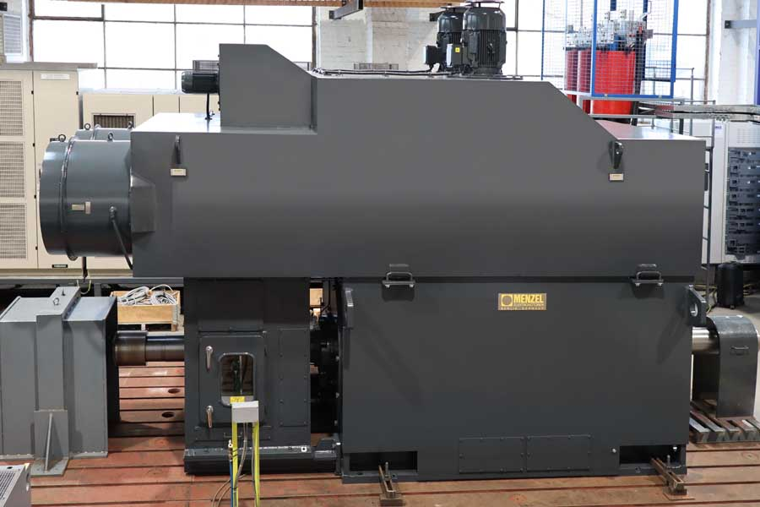
Caption: The custom-made slip ring motor with two shaft ends can replace two different mill motors as well as a fan motor – this saves money and space in spare parts management

Image/s: | menzel_cement_motor_1_for_3 | Characters: | 1401
File name: | 202208021_pm_joker_motor_cement_en | Date: | 08-24-2022
About Menzel Elektromotoren
Based in Berlin, Menzel Elektromotoren GmbH has been manufacturing and distributing electric motors since 1927. The medium-sized company specializes in the delivery of large electric motors, including special models, within the shortest possible time. The product range comprises high and low voltage motors, DC motors, transformers, and frequency inverters. Services include motor production and short-term adaptation of stocked motors to application-specific requirements. In order to ensure fast deliveries to the customer at all times, the company maintains a very extensive inventory including more than 20,000 motors with a maximum performance of up to 15,000 kW. Qualified engineering, experienced staff, and state-of-the-art production and testing facilities help Menzel provide excellent reliability. Menzel operates subsidiaries in the UK, France, Italy, Spain, and Sweden, and cooperates with numerous partners worldwide.
Contact:  Menzel Elektromotoren GmbH  Mathis Menzel  Neues Ufer 19 – 25  10553 Berlin  Germany  Phone: +49 . 30 . 349 922-0  Email: info@menzel-motors.com  Internet: www.menzel-motors.com |  | gii die Presse-Agentur GmbH  Immanuelkirchstr. 12  10405 Berlin  Germany  Phone: +49 . 30 . 538 9650  Email: info@gii.de  Internet: www.gii.de

