Press Release

Temperature-controlled and hygienic protective camera enclosures for Specim FX10 and FX17

autoVimation expands its protective enclosure range for Specim FX10 and FX17 hyperspectral cameras by two new models. In addition to the standard enclosure for Specim cameras featuring protection class IP66/IP67, a stainless-steel version in hygienic design and a temperature-controlled version are now also available. Specim hyperspectral cameras are mainly used for foreign object detection, plastics sorting and drug concentration analysis in food and pharmaceutical processes. However, until now, no suitable, hygienically designed protective enclosures were available that could be safely installed above the production lines. autoVimation now closes this gap, launching the new camera enclosures made of AISI 316L (V4A) stainless steel, which withstand wet cleaning with aggressive cleaning agents. Gap-free enclosure surfaces and hygienic cable glands minimize the risk of contamination. The second innovation for Specim cameras, thermoelectrically temperature-controlled protective enclosures allow cameras with a permissible temperature range of 5 °C to 40 °C to be used in ambient temperatures up to -20 °C to 70 °C. The system provides camera cooling by up to 25 K below the ambient temperature. The enclosures can also be used to stabilize camera temperatures to increase measuring accuracy in critical applications.

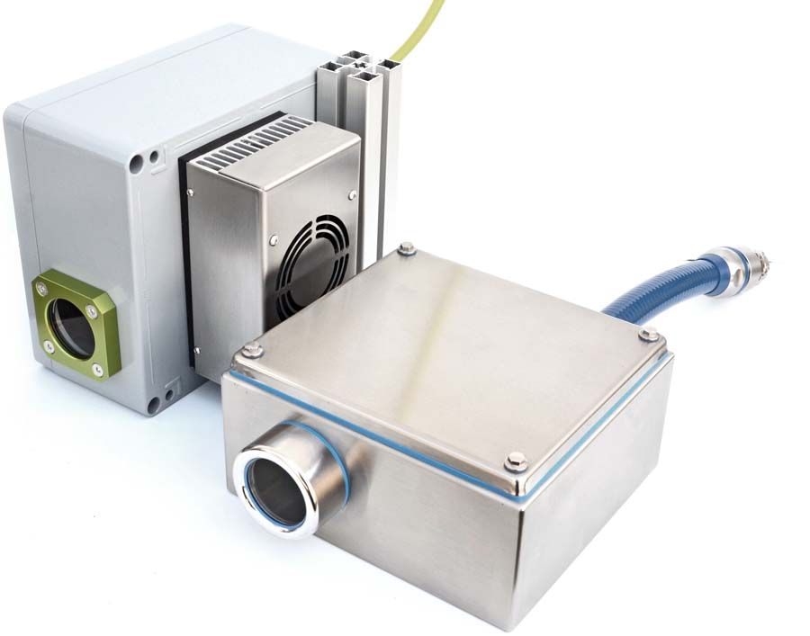
Caption: autoVimation supplies temperature-controlled and hygienic protective enclosures for Specim FX10 and FX17 hyperspectral cameras

Image/s: | Neue_Specim_Gehaeuse |  | Characters: | 1328
File name: | 202209024_pm_specim_fx10_fx17_enclosures_en |  | Date: | 10-26-2022
About autoVimation
The German manufacturer autoVimation was founded in 2008 by Peter Neuhaus to provide solutions for easier installation and adjustment of image processing components. The company has developed a modular construction kit that simplifies the connection of all required components, which does away with costly and time-consuming manufacturing of dedicated mounting brackets. The product portfolio also includes compact, easy-to-integrate enclosures that provide optimal protection for cameras and lenses in industrial applications, and ensure good heat dissipation. autoVimation supplies complete, ready-to-install mechanical solutions for cameras and light fittings, and enables the integration of special lenses, filters, light barriers, encoders, or other sensors.
autoVimation's customers include renowned companies from various industry branches, such as the pharmaceutical and food industry, measuring technology, quality control, and security technology.
Contact:  autoVimation GmbH  Peter Neuhaus  Roemerweg 1  76287 Rheinstetten  Germany  Phone: +49 . 721 . 627 6756  Email: sales@autovimation.com  Internet: www.autovimation.com |  | gii die Presse-Agentur GmbH  Immanuelkirchstr. 12  10405 Berlin  Germany  Phone: +49 . 30 . 538 9650  Email: info@gii.de  Internet: www.gii.de

