Press Release

Orca and Salamander enclosures optimized for easier camera mounting

In 2008, autoVimation introduced the Orca and Salamander series of protective camera enclosures with a patented camera mounting technology and standout features like compact size, high robustness and excellent heat dissipation. To celebrate the highly successful series’ 14th anniversary, the German manufacturer has examined the enclosures thoroughly and improved the design for even easier camera mounting. The enhanced Quick-Lock/Heat-Guide mounting system simplifies horizontal camera mounting inside the enclosure. The tolerance compensation is tripled, so cameras that deviate from the specified heights can still be precisely positioned. As a further innovation, Orca enclosures have a 10 mm slimmer camera mount and can now accommodate cameras up to 70 mm high at 50 mm maximum width. In addition, both Orca and Salamander enclosures feature new internal guides for precise alignment of cameras parallel to the outer wall: autoVimation added guides to the camera mounts, so users can now easily slide cameras with grooved housings into the cylindrical installation space, exactly parallel to the outer wall of the enclosure. If applications require rotated installation, users can easily dismantle the guides and affix the cameras as usual. Last but not least, autoVimation has simplified the replacement of enclosure windows, which are now fastened by retaining rings with holes. Using suitable pliers, the change takes only a very short time. For ESD-protected camera mounting, the manufacturer offers double-sided adhesive thermal conductive films with a dielectric strength of 3 kV, which offer high-level protection against electrostatic discharge in indoor or outdoor areas and prevent ground loops because of electric potential differences between camera and enclosure.

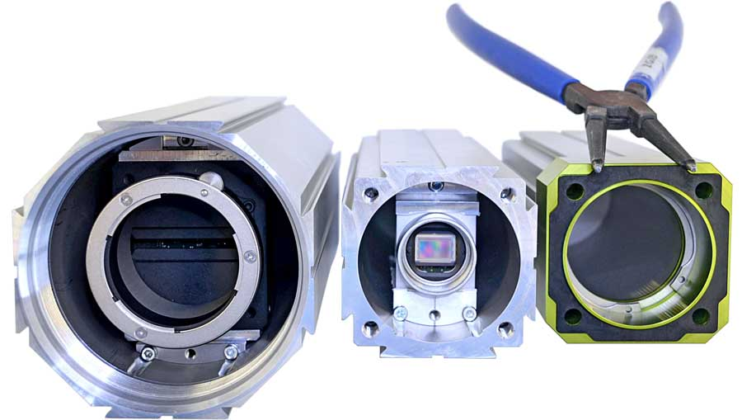
Caption: autoVimation has enhanced its protective enclosures Orca and Salamander for easier camera mounting

Image/s: | Salamander-_und_Orca-Geburtstag | Characters: | 1784
File name: | 202209025_pm_orca_salamander_optimized_en | Date: | 10-04-2022
About autoVimation
The German manufacturer autoVimation was founded in 2008 by Peter Neuhaus to provide solutions for easier installation and adjustment of image processing components. The company has developed a modular construction kit that simplifies the connection of all required components, which does away with costly and time-consuming manufacturing of dedicated mounting brackets. The product portfolio also includes compact, easy-to-integrate enclosures that provide optimal protection for cameras and lenses in industrial applications, and ensure good heat dissipation. autoVimation supplies complete, ready-to-install mechanical solutions for cameras and light fittings, and enables the integration of special lenses, filters, light barriers, encoders, or other sensors.
autoVimation's customers include renowned companies from various industry branches, such as the pharmaceutical and food industry, measuring technology, quality control, and security technology.
Contact:  autoVimation GmbH  Peter Neuhaus  Roemerweg 1  76287 Rheinstetten  Germany  Phone: +49 . 721 . 627 6756  Email: sales@autovimation.com  Internet: www.autovimation.com |  | gii die Presse-Agentur GmbH  Immanuelkirchstr. 12  10405 Berlin  Germany  Phone: +49 . 30 . 538 9650  Email: info@gii.de  Internet: www.gii.de

