Press Release

OEM laser profiler with integrated 3D image processing

Vision Components launches the new OEM laser profiler VC picoSmart 3D with integrated processors for 3D profile data analysis and further image processing tasks. All components are designed to function together perfectly: a miniaturized embedded vision system with a 1-megapixel image sensor, an FPGA and a high-end FPU processor and a line laser module with a blue high-power laser. The system is enclosed in a compact industrial-grade housing measuring only 100 mm x 40 mm x 41 mm and featuring a clear control panel and display. The integrated VC picoSmart is the world’s smallest embedded vision system, housed on a board the size of an image sensor. The FPGA is pre-programmed for 3D computation. The laser module, also an in-house development, operates reliably under bright ambient light up to 100,000 lux. The 130-mW laser is rated class 2. OEMs can implement their applications with minimal effort – from position detection to measurement to adhesive bead inspection and much more. The manufacturer offers company-specific labeling on request. VC picoSmart 3D is ideal for fast and economic development of individual OEM 3D sensors. All components are long-term available and optimized for series production.
Vision Components at the VISION trade fair
Stuttgart, Germany, 4 – 6 October 2022
Hall 8, Stand C31

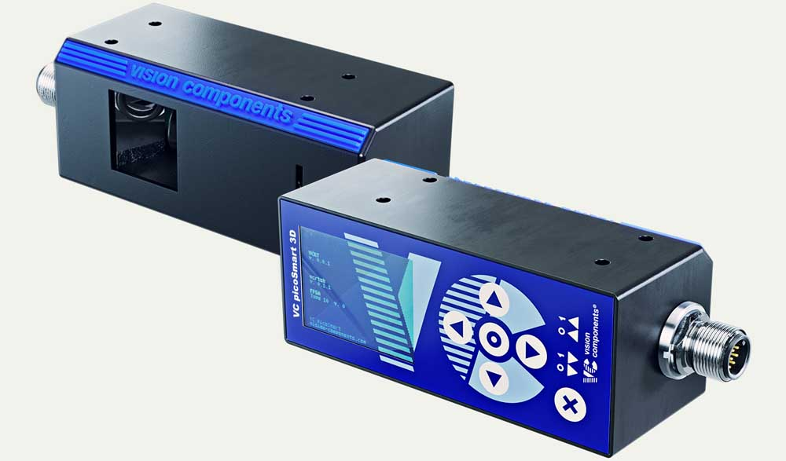
Caption: The new laser profiler VC picoSmart 3D allows flexible configuration and saves OEMs a lot of effort in developing their 3D applications

Image/s: | vc_picosmart_3d_oem_laser_profiler | Characters: | 1217
File name: | 202209027_pm_vc_picosmart_3d_en | Date: | 10-04-2022
About Vision Components
Vision Components is a leading international manufacturer of embedded vision systems. The freely programmable cameras with powerful onboard CPUs perform image processing tasks on their own without the need for an additional computer. Vision Components offers OEMs versatile Linux-based embedded systems for 2D and 3D image processing, supplied as board cameras or in protective casings. These are complemented by a growing range of ultracompact MIPI camera boards, which connect to a variety of different CPU boards. In addition, Vision Components offers software libraries and develops customized solutions on request. The team of experts can draw on extensive knowledge and over 20 years of experience with imaging applications. The company based in Ettlingen in southwestern Germany was founded in 1996 by Michael Engel, the inventor of the first industrial-grade intelligent camera. More world premieres followed, including the world's first intelligent vision sensors and the first-ever embedded 3D laser profiler. Today, Vision Components has sales offices in the United States and Japan and works with local partners in over 25 countries to provide consistent customer focus and readily available expertise throughout the world.
Contact:  Vision Components GmbH  Jan-Erik Schmitt  Ottostr. 2  76275 Ettlingen  Germany  Phone: +49 . 7243 . 21670  Email: schmitt@vision-components.com  Internet: www.vision-components.com |  | gii die Presse-Agentur GmbH  Immanuelkirchstr. 12  10405 Berlin  Germany  Phone: +49 . 30 . 538 9650  Email: info@gii.de  Internet: www.gii.de

