Press Release

EuroBLECH tradeshow:
Inline metal bending control with autonomous laser profiler

At the EuroBLECH tradeshow, Vision Components (booth 12-A02) will showcase its tested and proven laser profiler for angle measurement and inline control of sheet metal bending processes. The VC nano3D-Z laser triangulation sensor operates autonomously, without an external computing unit, and is already fully calibrated for angle measurement. It enables dynamic closed-loop contact pressure adjustment in press brakes and thereby an increase of both throughput and efficiency. The measurement resolution is better than +/- 0.05°. The easy-to-mount sensor connects to any controller/PLC and directly outputs the bending angle in degrees. The sensor is already integrated in DELEM and – new – CYBELEC controllers. Also new are a mounting kit and other accessories for easy commissioning. The rugged IP67-grade laser profiler is suitable for die widths from V6 to V200 and heights from 55 mm to 150 mm. Versions for larger dies are also available on request. The sensor delivers robust results even with reflective or brushed surfaces as well as perforated sheet metal. The German manufacturer Vision Components has developed it specifically as an OEM product and, in addition to the turnkey complete solution, also offers a modular kit for individual further development. The integrated embedded vision system and high-power blue laser (class 2) are perfectly matched. Press brake manufacturers receive proven, industrial-grade components with assured long-term availability.
Vision Components at EuroBLECH
Hanover, Germany, 25 – 28 October 2022
Hall 12, Stand A02

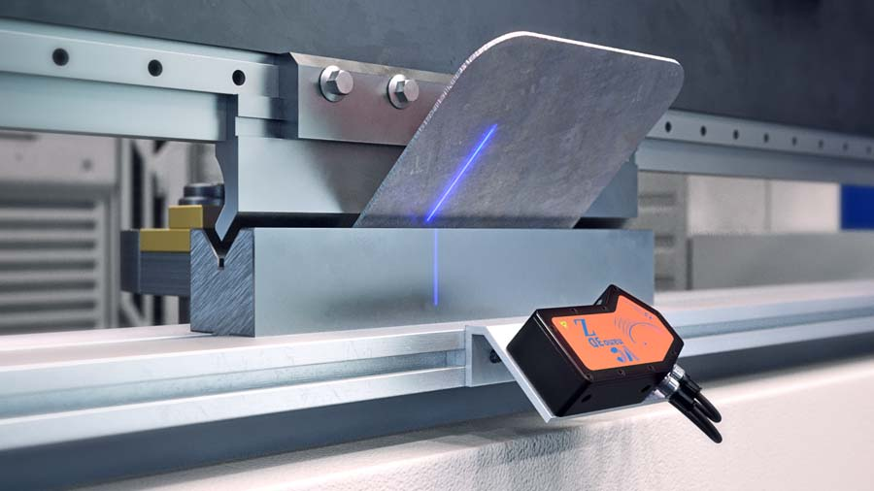
Caption: The profile sensor autonomously checks the angular accuracy during sheet metal bending and outputs real-time data for closed-loop process control

Image/s: | vcnano3d-z_press_brake | Characters: | 1474
File name: | 202210019_pm_euroblech_en | Date: | 10-13-2022
About Vision Components
Vision Components is a leading international manufacturer of embedded vision systems. The freely programmable cameras with powerful onboard CPUs perform image processing tasks on their own without the need for an additional computer. Vision Components offers OEMs versatile Linux-based embedded systems for 2D and 3D image processing, supplied as board cameras or in protective casings. These are complemented by a growing range of ultracompact MIPI camera boards, which connect to a variety of different CPU boards. In addition, Vision Components offers software libraries and develops customized solutions on request. The team of experts can draw on extensive knowledge and over 20 years of experience with imaging applications. The company based in Ettlingen in southwestern Germany was founded in 1996 by Michael Engel, the inventor of the first industrial-grade intelligent camera. More world premieres followed, including the world's first intelligent vision sensors and the first-ever embedded 3D laser profiler. Today, Vision Components has sales offices in the United States and Japan and works with local partners in over 25 countries to provide consistent customer focus and readily available expertise throughout the world.
Contact:  Vision Components GmbH  Jan-Erik Schmitt  Ottostr. 2  76275 Ettlingen  Germany  Phone: +49 . 7243 . 21670  Email: schmitt@vision-components.com  Internet: www.vision-components.com |  | gii die Presse-Agentur GmbH  Immanuelkirchstr. 12  10405 Berlin  Germany  Phone: +49 . 30 . 538 9650  Email: info@gii.de  Internet: www.gii.de

