Press Release

MICON 5 SAFETY: Micro key switch with two-channel contact system

MICON 5 tactile switches from RAFI are now also available in a new MICON 5 SAFETY version with a two-channel contact system. With a base of just 5.1 x 6.4 mm and a height of 3.85 mm, MICON 5 SAFETY key switches come in the same dimensions as MICON 5 key switches, but integrate two potential-free, separate NC and NO contacts. This means the micro key switches enable an especially cost-effective and space-saving design in applications that comply with functional safety standards such as DIN EN IEC 61508 (basic functional safety standard), DIN EN ISO 13849 (safety-related parts of control systems), DIN EN IEC 62061 (safety of control systems), DIN EN IEC 60601 (medical electrical equipment), DIN EN ISO 25119 (control systems for agricultural and forestry machines), DIN EN 50128 (rail applications), or ISO 26262 (road vehicles). Due to the optimized sealing system, MICON 5 SAFETY key switches comply with IP54 and/or IPx7 degrees of protection. With a temperature resistance of -40°C to +125°C, they also meet the current requirements of the automotive industry. For PCB assembly, the key switches feature SMT connection and are suitable for casting, painting, and nano-coating. Just like RAFI’s standard versions, MICON 5 SAFETY key switches feature a gold-contact system for reliable switching, excellent tactility, and a long operating life. The key switches are available for various operating forces and, depending on the version, they achieve up to one million operations. Thanks to the identical dimensions of the two ranges, the extensive MICON 5 accessory program of plungers and keycaps is equally suitable for MICON 5 SAFETY key switches.

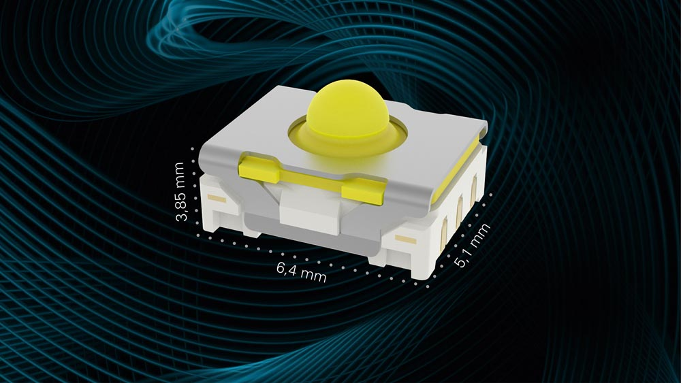
Caption: New MICON 5 SAFETY micro key switch with two-channel contact system

Image/s: | MICON_5_Safety | Characters: | 1658
File name: | 202210026_pm_MICON_5_SAFETY_en | Date: | 10-26-2022
About the RAFI Group
Founded in 1900, RAFI today develops and produces electromechanical components and systems for human–machine interaction. The range of products includes key switches, switches, touchscreens, control systems and electronic assemblies. RAFI products are employed in many industries including automation, medical technology, machine and plant engineering, road and railway vehicles, household appliances and telecommunication. The RAFI group operates internationally with more than 2,000 employees at sites in Germany, Europe, China, and the USA. Since 2020, it has been owned by the US investment company Oaktree. Its headquarters are in Berg, Germany.
Contact:
RAFI GmbH & Co. KG
Lisa Schuldt
Ravensburger Str. 128-134
88276 Berg
Germany
Phone: +49 . 751 . 891 516
Email: lisa-marija.schuldt@rafi-group.com
Internet: www.rafi-group.com

