Press Release

Automatic Easy Check for AC Charging Points

Gossen Metrawatt has introduced the new battery-operated PROFITEST H+E EASY CHECK for simple, safe testing of AC charging points at the touch of a button. No electric training is necessary to safely check infrastructures for single- and three-phase charging processes using this device, which corresponds to the CAT III 300V measurement category and is designed for 20A and 32A cables. Charging station operators, service providers and non-professionals can use the automatic device for function testing according to DIN EN/IEC 61851-1 (VDE 0122-1) in charging mode 3 at type-2 sockets or with a permanently installed type-2 cable. The functional range includes the verification of vehicle states A, B and C; phase tests and phase sequence tests; evaluation of the PWM signal for data communication and abortion of the charging process during short-circuit simulation; and determination of battery charge levels. Test results are shown in plain text on the device display and any detected malfunctions are saved as error messages. This way, if a charging process does not work properly, users can run quick and cost-efficient checks on the charging point or wallbox and need only call a qualified electrician if they detect functional errors. In addition to standards-compliant testing, the device is also suitable for complete professional functional testing of AC charging stations, thus eliminating the need for additional devices such as multimeters or oscillographs. Gossen Metrawatt supplies the PROFITEST H+E EASY CHECK complete with operating instructions and micro-USB charging cable.

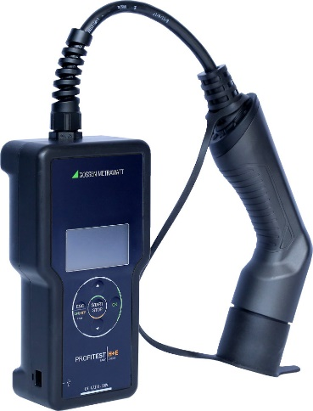
Caption: The new PROFITEST H+E EASY CHECK with automated test sequence ensures safe testing of AC charging points even by non-professionals

Image/s: | profitest-he-easy-check_2000.jpg | Characters: | 1593
File name: | 202210029_pm_profitest_h-e_easy_check_en | Date: | 11-22-2022
About Gossen Metrawatt
Gossen Metrawatt, one of the world’s leading suppliers of measurement systems, develops and distributes a wide range of high-quality measuring and test devices for electrical trade, various industries and the public sector.
The Gossen Metrawatt brand has been synonymous with safety and quality “Made in Germany” for decades. Its product range includes measurement and test technology for the electrical safety of plants, devices and machines as well as for the e-mobility and medical technology industries. Additional key areas of interest are power quality, battery testing technology, multimeters, calibrators, power supply technology and energy management systems. For a truly comprehensive electrical safety portfolio, Gossen Metrawatt also offers a continuously growing range of digital services and cloud services and supports its customers with a versatile training program and a wide range of after-sales services.
Gossen Metrawatt is part of the GMC Instruments Group, which also includes other specialized manufacturers for measurement and testing technology – notably, Camille Bauer Metrawatt, Dranetz, Prosys, Seaward and Rigel and Kurth Electronic. The Camille Bauer and Rigel brands add to the portfolio various transducers, display instruments and detection systems for heavy-current engineering as well as special measuring, testing and functional testing devices for the medical sector. The GMC-I Group runs its own DAkkS-certified calibration center that performs DAkkS, ISO and factory calibrations for virtually all electrical measured quantities. The GMC-I Group has development and production sites in Germany, Switzerland, England and the USA and a worldwide sales network of its own companies as well as sales partners.
Contact:  Gossen Metrawatt GmbH  Christian Widder  Head of Marketing Communication  Suedwestpark 15  90449 Nuremberg  Germany  Phone: +49 . 911 . 8602-572  Email: christian.widder@gossenmetrawatt.com  Internet: www.gossenmetrawatt.com |  | gii die Presse-Agentur GmbH  Immanuelkirchstr. 12  10405 Berlin  Germany  Tel.: +49 . 30 . 538 9650  Email: info@gii.de  Internet: www.gii.de

