Press Release

New PTKS 4 transformer terminals with time-saving push-in connection

The connection technology expert CONTA-CLIP has introduced a new series of particularly easy-to-install terminal blocks with innovative push-in wire connection for fast, tool-free wiring of transformers. The PTKS 4 transformer terminals for 4-mm² cable cross-sections are suitable both for direct mounting on the coil body and for snapping onto 10 mm x 2 mm aluminum mounting rails. Wires are pushed into the terminals' connection channels from above for easy contacting with no further wiring effort. The high contact force of the spring ensures secure, durable fixation and contacting that withstands even severe vibrations and mechanical shocks. Wires are disconnected in seconds by pressing the built-in, insulated pusher. Featuring a two-part construction consisting of the base terminal with freely accessible solder hooks and a cover, the PTKS 4 terminals can also be easily soldered onto the coil wires using automatic soldering methods. CONTA-CLIP offers terminal covers in various colors, e. g., for marking different voltages. The new terminal series enables test tapping at any potential. The program includes the PQI 4/x/PTKS series of pluggable, isolated cross connectors with 2, 3 and 5 poles for potential distribution. In future, the manufacturer will complete the new product segment by adding PTKS 4/SI 5x20 and PTKS 4/SI 6.3x32 transformer fuse terminals for contacting the corresponding fine fuses in 5 mm x 20 mm or 6.3 mm x 32 mm formats. CONTA-CLIP's SB 7,5 standard marking system is available for marking the terminals.

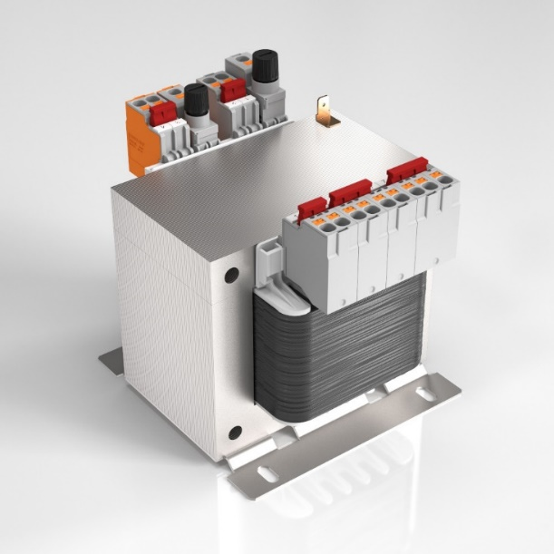
Caption: The newly developed PTKS 4 transformer terminals with push-in connection minimize the wiring effort

Image/s: | ptks_4_2000px.jpg | Characters: | 1545
File name: | 202211012_pm_ptks_4_transformer_terminals_en | Date: | 11-22-2022
About CONTA-CLIP
CONTA-CLIP is one of Europe’s leading manufacturers of electrical and electronic connection elements and cable management solutions. Based in Hövelhof, Germany, the medium-sized, family-run company has been producing electric and electronic connection systems for the process and automation industries since 1978. CONTA-CLIP supplies all industry sectors, focusing on railroad industries, shipbuilding, building automation, conveyor technology, machine and plant engineering and construction, instrumentation and control technology, control panel manufacturing, transformer manufacturing, and environmental technology. The company consists of many specialized branches: CONTA-CONNECT for electric connection technology, CONTA-CABLE for cable management systems, CONTA-ELECTRONICS for electronics and CONTA-CON for PCB edge connectors. Additionally, CONTA-CLIP provides services such as customizing housings and mounting rails, labeling and supplying user-specific electronic components.
Contact:  CONTA-CLIP  Verbindungstechnik GmbH  Franziska Klein  Otto-Hahn-Str. 7  33161 Hövelhof  Germany  Phone: +49 . 5257 . 9833 - 173  Email: franziska.klein@conta-clip.de  Internet: www.conta-clip.com |  | gii die Presse-Agentur GmbH  Immanuelkirchstr. 12  10405 Berlin  Germany  Phone: +49 . 30 . 538 965 - 0  Email: info@gii.de  Internet: www.gii.de

