Press Release

Adels-Contact and CONTA-CLIP establish strategic partnership

The connection technology expert CONTA-CLIP has entered into a partnership with Adels-Contact Elektrotechnische Fabrik for strategic development of transformer terminals. "Our cooperation in this competitive and very much in demand product segment taps the existing synergy potential and effectively concentrates both our companies' know-how in product development and production," says Andre Rumpff, Managing Partner at Adels-Contact.
"For two companies working in the field of electrical engineering, facing the same challenges, with similar company structures and based in the same geographic region in North Rhine-Westphalia, Germany, the partnership we have formed offers us a forward-looking way to serve customer demand even better and to strengthen our market position," says Jörg Nowastowski-Stock, Managing Director Sales/Marketing at CONTA-CLIP GmbH.
CONTA-CLIP is a leader in the cable management market and offers a complete range of terminal blocks with all connection types for all applications, including future markets such as electric charging infrastructure, solar or wind power. Adels-Contact is a manufacturer of connection terminals and plug connectors for building technology and the lighting and electrical industries, specializing in application solutions for versatile, sustainable electrical installation and energy-efficient devices and lighting.

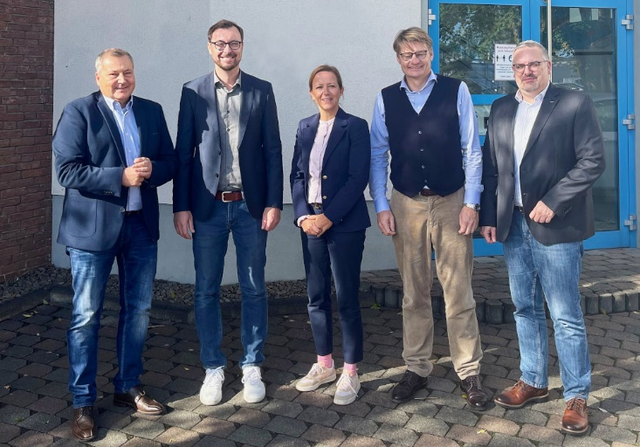
Caption: Jörg Nowastowski-Stock (CONTA-CLIP Managing Director Sales/Marketing), Markus Dusartz (Adels-Contact Sales Manager), Bianca Klass (CONTA-CLIP Managing Partner), Andre Rumpff (Adels-Contact Managing Partner), Ralf Begemann (CONTA-CLIP Product Manager; from left to right)

Image/s: | strapa_cc_ac_2000.jpg | Characters: | 1372
File name: | 202211013_pm_adels-contact_partnership_en | Date: | 11-08-2022
About CONTA-CLIP
CONTA-CLIP is one of Europe’s leading manufacturers of electrical and electronic connection elements and cable management solutions. Based in Hövelhof, Germany, the medium-sized, family-run company has been producing electric and electronic connection systems for the process and automation industries since 1978. CONTA-CLIP supplies all industry sectors, focusing on railroad industries, shipbuilding, building automation, conveyor technology, machine and plant engineering and construction, instrumentation and control technology, control panel manufacturing, transformer manufacturing, and environmental technology. The company consists of many specialized branches: CONTA-CONNECT for electric connection technology, CONTA-CABLE for cable management systems, CONTA-ELECTRONICS for electronics and CONTA-CON for PCB edge connectors. Additionally, CONTA-CLIP provides services such as customizing housings and mounting rails, labeling and supplying user-specific electronic components.
Contact:  CONTA-CLIP  Verbindungstechnik GmbH  Franziska Klein  Otto-Hahn-Str. 7  33161 Hövelhof  Germany  Phone: +49 . 5257 . 9833 - 173  Email: franziska.klein@conta-clip.de  Internet: www.conta-clip.com |  | gii die Presse-Agentur GmbH  Immanuelkirchstr. 12  10405 Berlin  Germany  Phone: +49 . 30 . 538 965 - 0  Email: info@gii.de  Internet: www.gii.de

