Press Release

Thermal air flow controllers with IO-Link interface

EGE presents new air flow controllers with an IO-Link interface and additional temperature measurement. The sensors for gaseous non-explosive media are available in two designs: LN 520 GPL with a smooth sleeve with a 20-mm diameter and LG 518 GPL with a male M18x1 thread. They measure flow velocities from 0.5 to 15 m/s and temperatures from -20 °C to 70 °C. Limit values and additional operating parameters can be freely set via the IO-Link interface. The sensors store minimum and maximum values onboard. Color LEDs on the cable outlet signal the flow state, the reaching of set limit values and connection to an IO-Link primary, or support visual identification in larger systems by flashing. For further processing in SIO mode, the PNP switching output is available – and in IO-Link mode, the process data with measured values for flow and temperature. The flow value is output in non-linear proportion to the air flow. The air flow controllers feature IP67 protection and fulfill the current IO-Link specification V 1.1.3. Reaction times are in the range of 2 to 20 s for flow changes and <15 s for temperature changes. The LN 520 GPL model with a smooth sleeve is supplied complete with a mounting flange.

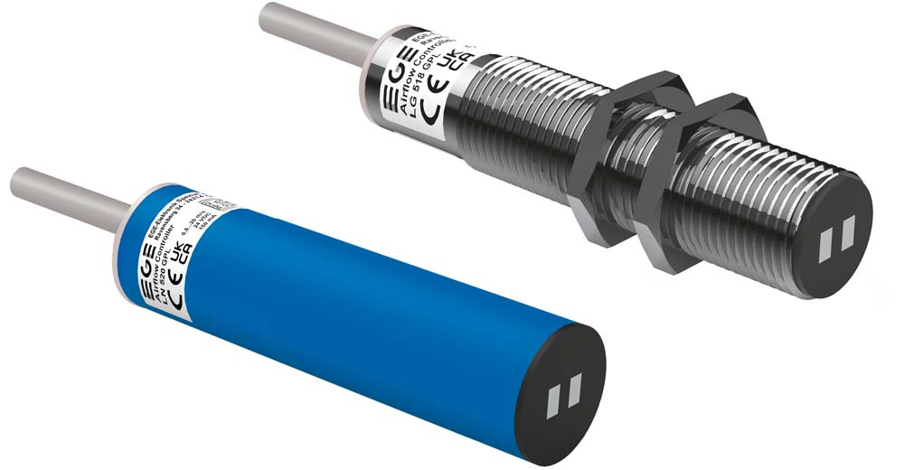
Caption: The compact sensors transmit flow velocity and temperature via IO-Link

Image/s: | io-link_air_flow_controller_ln_520__lg_518_gpl | Characters: | 1212
File name: | 202211014_pm_io-link_air_flow_controllers_en | Date: | 12-14-2022
About EGE
EGE-Elektronik Spezial-Sensoren GmbH has been developing and manufacturing special purpose sensors for automation applications since 1976. The company serves leading international producers from a wide range of industries. Its product portfolio includes flow controllers, infrared, opto and ultrasonic sensors, capacitive proximity switches, light barriers and inductive proximity switches. EGE also provides sensors for highly sensitive applications, e.g. hazardous areas. The development department's highly qualified staff cooperates closely with all customers, ensuring continuous product updates and enhancement. A total of 130 employees, including 20 engineers and technicians, generate gross sales of approx. 19.5 million Euros worldwide.
Contact:  EGE-Elektronik Spezial-Sensoren GmbH  Sven-Eric Hiss  Ravensberg 34  24214 Gettorf  Germany  Phone: +49 . 4346 . 4158-0  Email: info@ege-elektronik.com  Internet: www.ege-elektronik.com |  | gii die Presse-Agentur GmbH  Immanuelkirchstr. 12  10405 Berlin  Germany  Phone: +49 . 30 . 538 9650  Email: info@gii.de  Internet: www.gii.de

