Press Release

RAFI Electronics expands production capacities

Last December, the RAFI Group’s Chinese branch, RAFI Electronics, moved into its new production facility in Shanghai. In the new factory in Quingpu, RAFI Electronics has a production area of 7,800 m², of which 4,600 m² is a clean room area for the production of electronics using SMT and THT assembly. The HMI specialist will use five SMT lines to produce mainly electronics for the medical technology, robotics, and automotive industries. The other 3,200 m² of production space is allocated to product assembly. With cutting-edge energy supply technology, RAFI Electronics also meets its green responsibilities: Installed on the roof is a solar power system with an area of 2,200 m² and a capacity of 200 KVA. It powers a micro grid with an energy storage system.
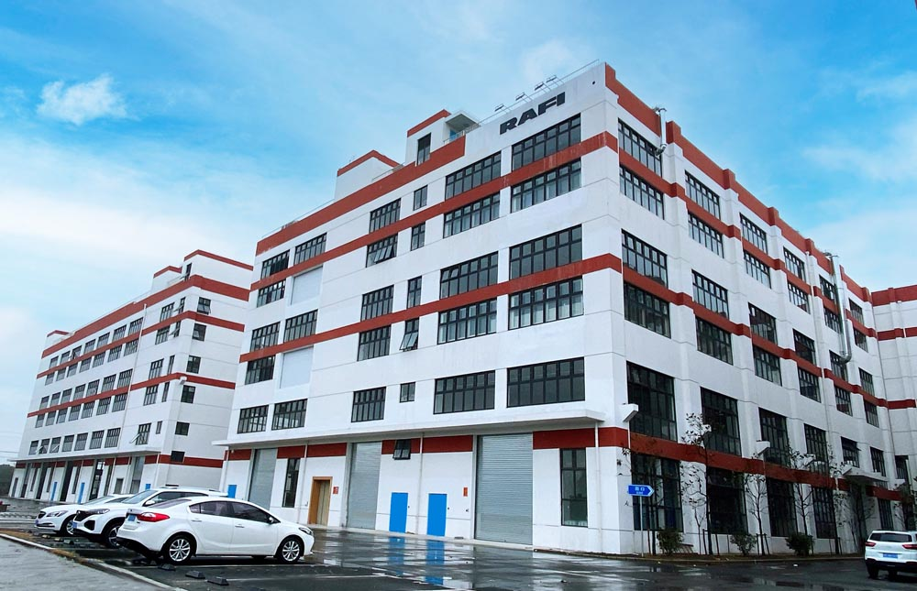
Caption: After occupying its new factory in Quingpu district, RAFI Electronics has considerably expanded its production capacities in Shanghai.

On the opening date on December 22, 2021, Zhu Mingfu, Director of the Standing Committee of the People’s Congress of Qingpu District, visited the new factory and praised the sustainable development of the industrial park, which he called a win-win situation for all stakeholders. Thanks to the new factory, RAFI Electronics can not only considerably expand its production capacities, but also moves closer to the Asian markets. Simultaneously, RAFI customers in Europe and the USA benefit from the good price-performance ratio the manufacturer achieves by purchasing components in China. On this basis, RAFI with its production locations in Germany, Italy, Hungary, the USA, and China, can offer ideal solutions for every customer requirement.

Image/s: | RAFI-Electronics_Quingpu_2021 | Characters: | 1,508
File name: | 202212001_pm_RAFI-China_neues_Werk_en | Date: | 02-16-2022

About the RAFI group
Founded in 1900, RAFI today develops and produces electromechanical components and systems for human–machine interaction. The range of products includes key switches, switches, touchscreens, control systems and electronic assemblies. RAFI products are employed in many industries including automation, medical technology, machine and plant engineering, road and railway vehicles, household appliances and telecommunication. The RAFI group operates internationally with more than 2,000 employees at sites in Germany, Europe, China, and the USA. Since 2020, it has been owned by the investment company Oaktree. Its headquarters are in Berg, Germany.

Contact:  RAFI Group  Artur Krug  Ravensburger Str. 128–134  88276 Berg, Germany  Phone: +49 751 89-1307  Email: artur.krug@rafi-group.com  Internet: www.rafi-group.com |  | gii die Presse-Agentur GmbH  Immanuelkirchstr. 12  10405 Berlin, Germany  Phone: +49 30 53 89 65-0  Email: info@gii.de  Internet: www.gii.de

