Press Release

Topping out at new Menzel motor plant

Menzel Elektromotoren celebrated the topping out of its new headquarters on the outskirts of Berlin, Germany, on 16 December 2022. This modern electric motor plant being built on a 24,000 m² plot will accommodate approx. 6,500 m² of production area, along with spacious offices and a cafeteria. The new factory will feature the capacity to manufacture and test larger, heavier drive systems. The production flow will be optimized, and Menzel will create numerous new jobs. The established, family-run company manufactures large AC and DC motors up to 20 MW for industrial facilities all over the world and, thanks to its huge inventory, can also adapt drives for any requirements at short notice. The experienced team provides individual and reliable service, first-rate product quality and expert advice on drive applications in all kinds of industries.
Construction diary with many photos: https://www.menzel-motors.com/article/photo-report-new-electric-motor-plant/

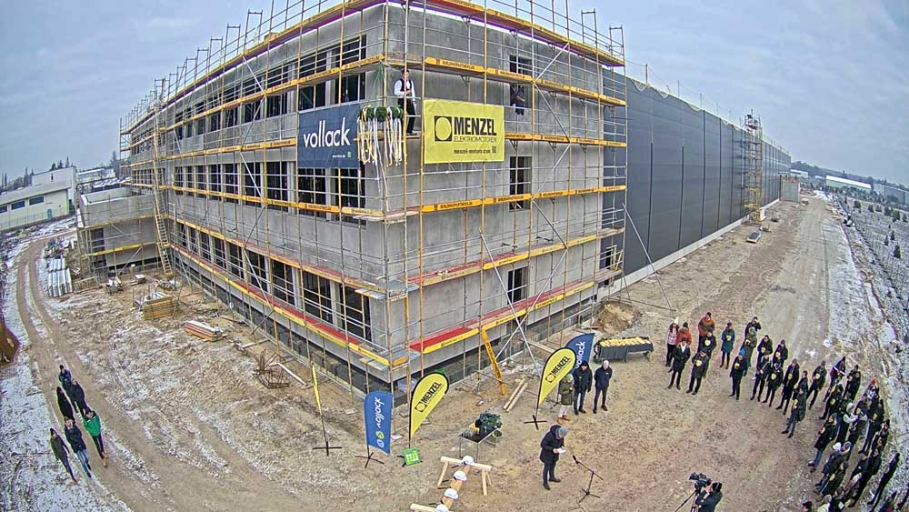
Caption: The new Menzel Elektromotoren headquarters will be completed in the summer of 2023

Image/s: | hennigsdorf_topping_out |  | Characters: | 854
File name: | 202212006_pm_topping_out_of_motor_plant_en |  | Date: | 12-19-2022
About Menzel Elektromotoren
Based in Berlin, Menzel Elektromotoren GmbH has been manufacturing and distributing electric motors since 1927. The medium-sized company specializes in the delivery of large electric motors, including special models, within the shortest possible time. The product range comprises high and low voltage motors, DC motors, transformers, and frequency inverters. Services include motor production and short-term adaptation of stocked motors to application-specific requirements. In order to ensure fast deliveries to the customer at all times, the company maintains a very extensive inventory including more than 20,000 motors with a maximum performance of up to 15,000 kW. Qualified engineering, experienced staff, and state-of-the-art production and testing facilities help Menzel provide excellent reliability. Menzel operates subsidiaries in the UK, France, Italy, Spain, and Sweden, and cooperates with numerous partners worldwide.
Contact:  Menzel Elektromotoren GmbH  Mathis Menzel  Neues Ufer 19 – 25  10553 Berlin  Germany  Phone: +49 . 30 . 349 922-0  Email: info@menzel-motors.com  Internet: www.menzel-motors.com |  | gii die Presse-Agentur GmbH  Immanuelkirchstr. 12  10405 Berlin  Germany  Phone: +49 . 30 . 538 9650  Email: info@gii.de  Internet: www.gii.de

