Press Release

Free webinar:
Real-time angle measurement in sheet metal bending

Vision Components will host two webinars on 24 January, demonstrating the operation and integration of autonomous angle measurement in metal processing. Thanks to the integrated processor, the sensor directly outputs the workpiece angle in degrees.
The free-of-charge webinars are aimed in particular at manufacturers and distributors of press brakes and metal forming technology. Jan-Erik Schmitt, Vice President Sales, and Klaus Schneider, VC Chief Engineer for Angle Measurement, present the advantages of VC nano 3D-Z laser profilers, which do not require an external processing unit, can be connected directly to machine controls and enable real-time adjustment of the bending process. Following a live demonstration of the solution, Klaus Schneider will be available for individual questions and consultations.
The 3D sensors, optimized for sheet metal bending and fully calibrated, are easy to integrate in press brakes. The system is already integrated by default in controllers from CYBELEC, DELEM and STEP AUTOMATION and only needs to be activated. The sensor has a wide detection range and can cover dies from V6 to V200 from a fixed mounting position, providing a typical accuracy of +/- 0.1°.
Timings: 24 January 2023, 11:30 a.m. & 5:30 p.m. CET
Language: English
Learn more and register free of charge: https://www.vision-components.com/en/events/kostenloses-webinar-angle-measurement-on-press-brakes/

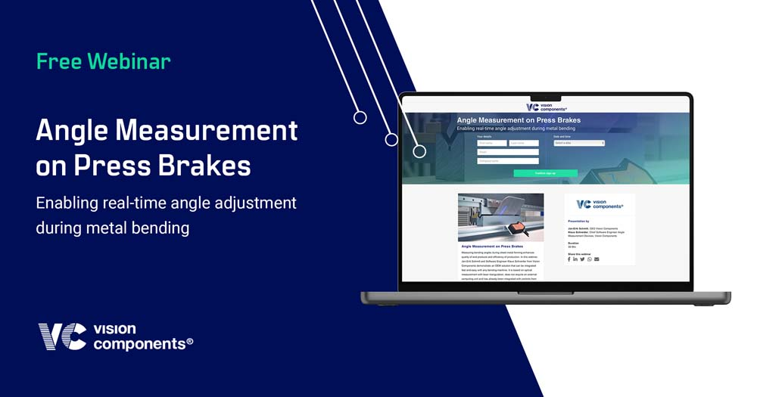
Caption: Participation in Vision Components’ webinar “Angle Measurement on Press Brakes” is free of charge

Image/s: | vc_webinar_angle_measurement | Characters: | 1410
File name: | 202301007_pm_angle_measure_webinar_en | Date: | 01-10-2023
About Vision Components
Vision Components is a leading international manufacturer of embedded vision systems. The freely programmable cameras with powerful onboard CPUs perform image processing tasks on their own without the need for an additional computer. Vision Components offers OEMs versatile Linux-based embedded systems for 2D and 3D image processing, supplied as board cameras or in protective casings. These are complemented by a growing range of ultracompact MIPI camera boards, which connect to a variety of different CPU boards. In addition, Vision Components offers software libraries and develops customized solutions on request. The team of experts can draw on extensive knowledge and over 20 years of experience with imaging applications. The company based in Ettlingen in southwestern Germany was founded in 1996 by Michael Engel, the inventor of the first industrial-grade intelligent camera. More world premieres followed, including the world's first intelligent vision sensors and the first-ever embedded 3D laser profiler. Today, Vision Components has sales offices in the United States and Japan and works with local partners in over 25 countries to provide consistent customer focus and readily available expertise throughout the world.
Contact:  Vision Components GmbH  Jan-Erik Schmitt  Ottostr. 2  76275 Ettlingen  Germany  Phone: +49 . 7243 . 21670  Email: schmitt@vision-components.com  Internet: www.vision-components.com |  | gii die Presse-Agentur GmbH  Immanuelkirchstr. 12  10405 Berlin  Germany  Phone: +49 . 30 . 538 9650  Email: info@gii.de  Internet: www.gii.de

