Press Release

4.5 MW 11 kV replacement motor ready in 3 weeks

Menzel Elektromotoren quickly provided a replacement motor for one of India’s largest industrial and medical gas manufacturers. When a large compressor motor failed, causing production losses, Menzel adapted a stock motor, ready for shipping within three weeks of receiving the order. The family-run German company ensured smooth commissioning by various steps. Works included electrical reconnecting of the motor windings to meet the required voltage level and starting properties; manufacturing a special tapered shaft end for shrink fit; and drilling new foot mounting holes. Menzel maintains an extensive stock of large industrial motors, including several own motor series with very good power densities and long lifespans. In this case, the manufacturer supplied a squirrel cage induction motor from its MEBKSW series, with the same characteristics as the failed motor: frame size 630 mm, 4.5 MW nominal power, 11 kV nominal voltage. The motor has an IP 55 degree of protection and features totally enclosed water to air cooling (TEWAC / cooling type IC 81W). The concluding thorough motor checks in Menzel’s inhouse test field were attended by the customer’s own test engineer who satisfied himself that the motor was in full working order.
Menzel references for compressor motors: https://www.menzel-motors.com/compressor-drive/

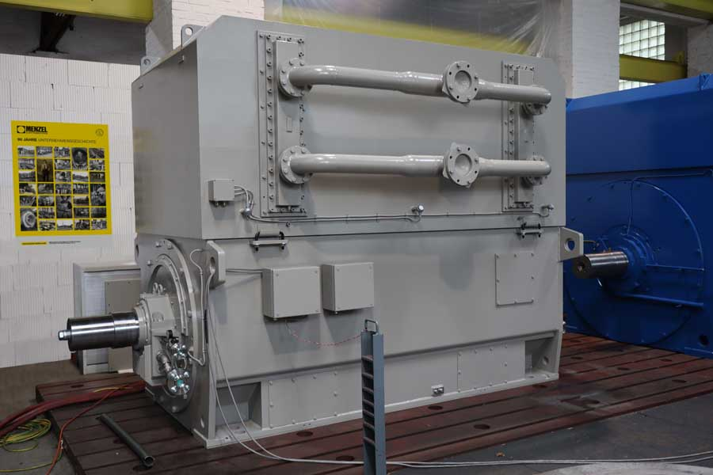
Caption: Menzel had a suitable replacement motor on stock and performed all electrical and mechanical adaptations as well as inspections inhouse

Image/s: | compressor_motor_h11413_india |  | Characters: | 1247
File name: | 202301014_pm_4mw_compressor_motor_en |  | Date: | 02-08-2023
About Menzel Elektromotoren
Based in Berlin, Menzel Elektromotoren GmbH has been manufacturing and distributing electric motors since 1927. The medium-sized company specializes in the delivery of large electric motors, including special models, within the shortest possible time. The product range comprises high and low voltage motors, DC motors, transformers, and frequency inverters. Services include motor production and short-term adaptation of stocked motors to application-specific requirements. In order to ensure fast deliveries to the customer at all times, the company maintains a very extensive inventory including more than 20,000 motors with a maximum performance of up to 15,000 kW. Qualified engineering, experienced staff, and state-of-the-art production and testing facilities help Menzel provide excellent reliability. Menzel operates subsidiaries in the UK, France, Italy, Spain, and Sweden, and cooperates with numerous partners worldwide.
Contact:  Menzel Elektromotoren GmbH  Mathis Menzel  Neues Ufer 19 – 25  10553 Berlin  Germany  Phone: +49 . 30 . 349 922-0  Email: info@menzel-motors.com  Internet: www.menzel-motors.com |  | gii die Presse-Agentur GmbH  Immanuelkirchstr. 12  10405 Berlin  Germany  Phone: +49 . 30 . 538 9650  Email: info@gii.de  Internet: www.gii.de

