Press Release

embedded world:
Fast-track embedded vision integration

At embedded world, Vision Components will present new MIPI camera modules and components for even more efficient and faster implementation of embedded vision projects. The highlight will be the FPGA-based hardware accelerator VC Power SoM, which completes complex image processing calculations and transfers the results directly to a processor board. The module is extremely compact at only 28 mm x 24 mm. It features mature FPGA technology and comprehensive image processing functionalities. It can be directly integrated into embedded vision mainboard designs as a module or combined with an I/O board with multiple MIPI interfaces. Using the VC Power SoM, OEMs can employ the full computing power of their preferred embedded processor board for the main application. At embedded world, Vision Components will give first insights into its work on FPGA designs for applications such as color conversion, 1D barcode identification, epipolar correction, etc.

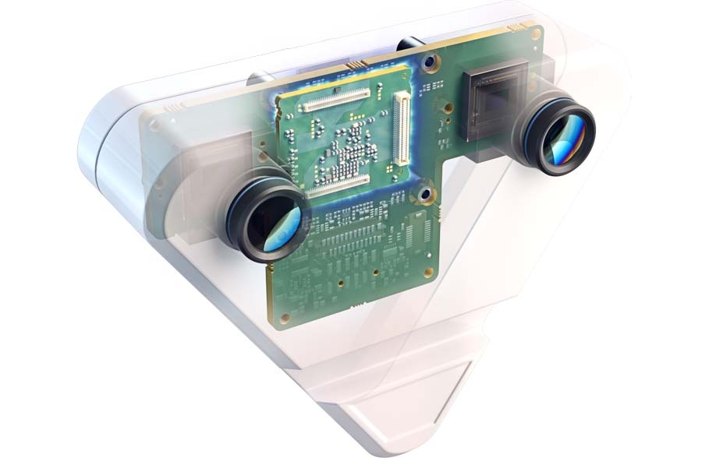
Caption: Sample application with VC Power SoM: stereo camera with direct data processing on the edge device

Additional prominent exhibits include VC MIPI camera modules with SONY Pregius S series sensors and new MIPI cameras for SWIR and 3D/ToF applications. All products are developed and produced by Vision Components in Germany.
Trade fair visitors are also invited to the presentation by Jan-Erik Schmitt, VC CEO, at the embedded world Conference: "Smart Devices for a Better World: The Embedded Vision Revolution" (Session 7.1, 16 March, 11 – 11.30 a.m.). He will sketch out the evolution of embedded vision over the past 25 years and demonstrate how state-of-the-art embedded vision systems with technologies such as the MIPI interface and the smart combination of specialized processing units are easier to integrate into electronic designs than ever before. Many real-life examples and possible future applications will be presented, encouraging everyone to partake and to bring embedded vision into their next product.
Vision Components at embedded world
Nuremberg, Germany, 14 – 16 March 2023
Hall 2, Stand 450

Image/s: | vc_stereo_camera_case_ghosting | Characters: | 1875
File name: | 202301017_pm_embedded_world_en | Date: | 01-31-2023
About Vision Components
Vision Components is a leading international manufacturer of embedded vision systems. The freely programmable cameras with powerful onboard CPUs perform image processing tasks on their own without the need for an additional computer. Vision Components offers OEMs versatile Linux-based embedded systems for 2D and 3D image processing, supplied as board cameras or in protective casings. These are complemented by a growing range of ultracompact MIPI camera boards, which connect to a variety of different CPU boards. In addition, Vision Components offers software libraries and develops customized solutions on request. The team of experts can draw on extensive knowledge and over 20 years of experience with imaging applications. The company based in Ettlingen in southwestern Germany was founded in 1996 by Michael Engel, the inventor of the first industrial-grade intelligent camera. More world premieres followed, including the world's first intelligent vision sensors and the first-ever embedded 3D laser profiler. Today, Vision Components has sales offices in the United States and Japan and works with local partners in over 25 countries to provide consistent customer focus and readily available expertise throughout the world.
Contact:  Vision Components GmbH  Jan-Erik Schmitt  Ottostr. 2  76275 Ettlingen  Germany  Phone: +49 . 7243 . 21670  Email: schmitt@vision-components.com  Internet: www.vision-components.com |  | gii die Presse-Agentur GmbH  Immanuelkirchstr. 12  10405 Berlin  Germany  Phone: +49 . 30 . 538 9650  Email: info@gii.de  Internet: www.gii.de

