Press Release

Expomin Chile:
Powerful motors for conveyors, fans and mills

At the Expomin trade fair, Menzel Elektromotoren (German pavilion, booth #9-C05) will present its motor range for the mining industry and capability to answer special customer requirements quickly and flexibly. The family-run German manufacturer supplies mines worldwide with large-scale electric motors for conveyors, fans, mills and crushers: high, medium and low-voltage motors, induction motors with slipring rotors up to 15 MW and with squirrel cage rotors up to 25 MW as well as DC motors up to 2 MW. Menzel specializes in customized motor construction and fast supply of replacement motors. The manufacturer’s standard motor series have excellent mechanical and thermal properties, which ensure efficient, low-maintenance operation and long lifespans. Menzel also has one of the largest stocks of motors and accessories, which experienced motor engineers quickly adapt for urgent orders. Special dimensions, electrical properties, cooling types, protection degrees or extreme load characteristics are no problem. Designing its drives, Menzel also observes the climatic locations at the customer’s site.
Menzel references: https://www.menzel-motors.com/references/
Menzel Elektromotoren at Expomin
Santiago de Chile, 24. – 27. April 2023
Hall 9, Booth C05 (German pavilion)

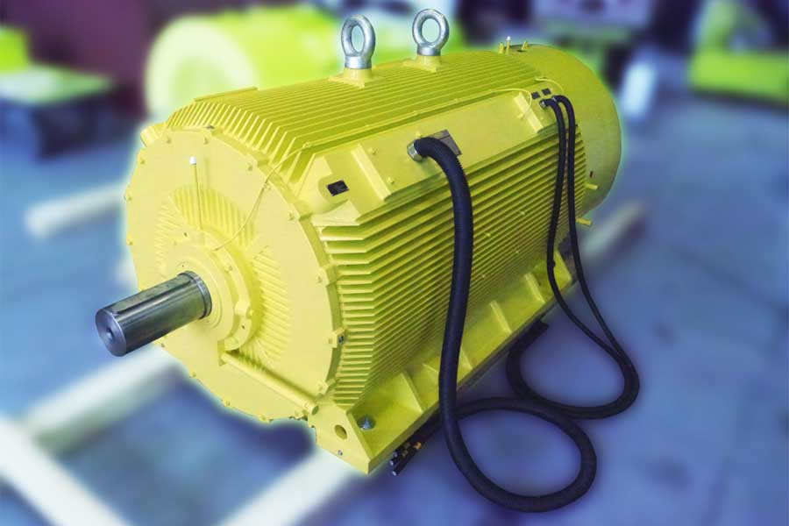
Caption: Menzel checks all motors in its inhouse test field to ensure optimum operation, like this motor tailored for direct integration inside pit fans

Image/s: | menzel_pit_fan_motor_squirrel_cage | Characters: | 1109
File name: | 202302012_pm_expomin_chile_en | Date: | 02-22-2023
About Menzel Elektromotoren
Based in Berlin, Menzel Elektromotoren GmbH has been manufacturing and distributing electric motors since 1927. The medium-sized company specializes in the delivery of large electric motors, including special models, within the shortest possible time. The product range comprises high and low voltage motors, DC motors, transformers, and frequency inverters. Services include motor production and short-term adaptation of stocked motors to application-specific requirements. In order to ensure fast deliveries to the customer at all times, the company maintains a very extensive inventory including more than 20,000 motors with a maximum performance of up to 15,000 kW. Qualified engineering, experienced staff, and state-of-the-art production and testing facilities help Menzel provide excellent reliability. Menzel operates subsidiaries in the UK, France, Italy, Spain, and Sweden, and cooperates with numerous partners worldwide.
Contact:  Menzel Elektromotoren GmbH  Mathis Menzel  Neues Ufer 19 – 25  10553 Berlin  Germany  Phone: +49 . 30 . 349 922-0  Email: info@menzel-motors.com  Internet: www.menzel-motors.com |  | gii die Presse-Agentur GmbH  Immanuelkirchstr. 12  10405 Berlin  Germany  Phone: +49 . 30 . 538 9650  Email: info@gii.de  Internet: www.gii.de

