Press Release

P48-30 ultrasonic barrier with optimized connection solution

The sensor specialist PiL has optimized its economical, easy-to-install P48-30 series ultrasonic sensors and now offers a common Y-connector with M12 output for the transmitter and receiver. This allows the previously separate connections to be easily and practically connected to connect both sensor modules to the signal processing as one device using M12 sensor cables. The P48-30 model series is specified for non-contact detection of light, dark and transparent objects in a detection range up to 300mm. Its sound cone aperture of 15° ensures reliable object detection, which – unlike optical systems – is not affected by dust, smoke or refractive geometries. Any interruption of the detection area triggers a switching signal with a maximum switching frequency of 150Hz. Due to its short response time of 1ms, the P48-30 ultrasonic barrier is ideal for product or pack counting on conveyor belts even at high belt speeds. Its measurement sensitivity in the mm range also ensures the detection of very thin materials, for example for foil detection. The sensor modules, which are very compact with dimensions of 30x20x10mm and are manufactured in protection class IP67, can be used in a temperature range from -15°C to +60°C. The sensor modules can also be used in a wide range of applications. An LED integrated in the receiver unit is used for function display. A short product video is available at https://youtu.be/0WC01wbQrlQ.
PiL offers comprehensive application know-how and responds flexibly to customer requirements at all times. And where application-specific parameterization is not sufficient, the manufacturer is also happy to support its customers on request with individually customized solutions. The development and manufacturing facilities of the specialist for industrial ultrasonic sensor technology are in Germany.

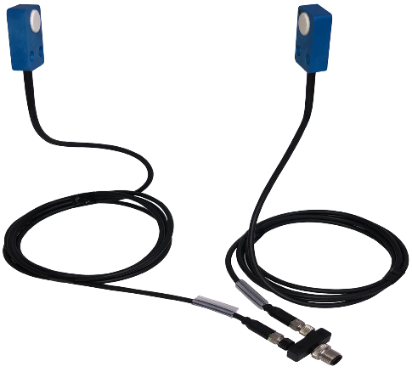
Caption: Optimized PiL ultrasonic barrier with new Y-connector for common M12 sensor connection of transmitter and receiver

Image/s: | ultraschallschranke_p48-30 | Characters: | 1839
File name: | 202303027_pm_ p48-30_ultrasonic_barrier_en | Date: | 04-05-2023
About PIL
PiL Sensoren GmbH, with its headquarters in Erlensee near Frankfurt/Main is a pioneer of ultrasonic technology and has been developing, producing, and selling standard and customized sensor solutions for industrial applications since 1990. Together with Inelta Sensorsystem GmbH & Co. KG (Taufkirchen near Munich) and VYPRO s.r.o. (Trenčín, Slovakia), PiL offers a wide range of products for measuring displacement and position as well as force, pressure, and inclination. The range of products we offer includes force sensors, sensor signal amplifiers, pressure switches, capacitive sensors, and ultrasonic sensors. Our portfolio is nicely rounded off with cable and connector assembly services.
Most of the group of companies’ customers are in industrial automation, mechanical engineering, hydraulics, medical technology as well as the aerospace industry. We especially focus on industry and customer-specific sensor solutions and are constantly expanding this focus with interdisciplinary know-how.
Contact:  PIL Sensoren GmbH  Zweigstelle Süd  Reinhard Koch  Ludwig-Boelkow-Allee 22  82024 Taufkirchen  Germany  Phone: +49 89 / 452 245-0  Fax: +49 89 / 452 245-744  Email: marketing@pil.de  Internet: www.pil.de |  | gii die Presse-Agentur GmbH  Immanuelkirchstr. 12  10405 Berlin  Germany  Phone: +49 . 30 . 538 965 - 0  Email: info@gii.de  Internet: www.gii.de

