Press Release

LogiMAT trade fair:
LOYSCO intra-logistics and material handling solutions

LOSYCO will showcase innovative solutions for intra-logistics, material flow and machine loading at the LogiMAT trade fair in Stuttgart, Germany, 25 – 27 April 2023, Hall 7, Stand F41. Co-presenting with the mechanical engineering supplier DRECKSHAGE at a completely redesigned booth, the German intra-logistics specialist will exhibit new developments and completed applications for one-piece flow production and precision feeding based on its LOXrail floor-level rail transport system. LOSYCO's trade fair premieres include a newly developed automatic trolley with an integrated turning function and a compact version of the successful LOXrail AllRounder. The steerable AllRounder trolley is designed for payloads up to 15 tons and allows workpieces and assemblies to be aligned and rotated without lifting them off the trolley. It is offered with either a mechanical steering system mounted on the underside of the carrier or semi-automatic steering. Additional trade fair highlights will be demos of various applications implemented by LOSYCO for material feeding and flow production. One model shows the production line recently set up for an excavator and wheel loader manufacturer with customized trolleys and turntables integrated in the floor. Another example is taken from modular timber housing construction: the trolleys carrying the building modules are moved to a parallel production line on a cross-shuttle installed in the concrete floor. The third model will be a high-precision loading system designed for a laser welding booth, consisting of trolleys with lifting function, which can be equipped for manual operation or with auxiliary drives and a control system. The LOSYCO team is looking forward to welcoming visitors to the booth and discussing their intra-logistics requirements and customized solutions.

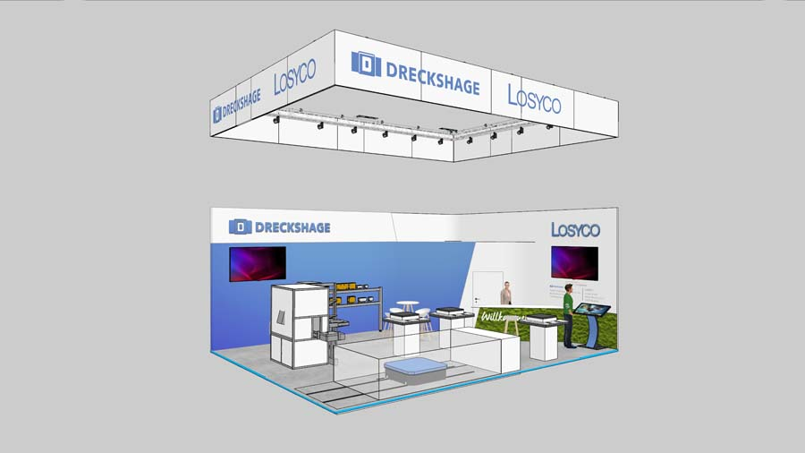
Caption 1: LOSYCO will present new developments and applications for one-piece flow production and precision feeding at its newly designed LogiMAT booth

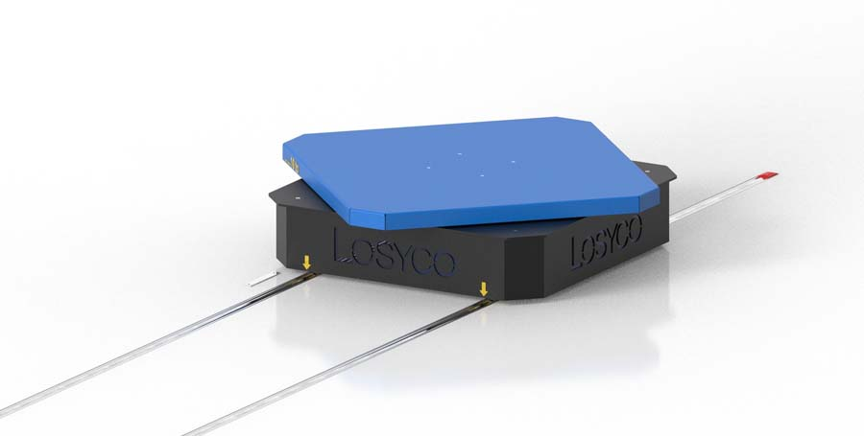
Caption 2: One of LOSYCO's trade fair innovations at LogiMAT (Hall 7, Stand F41) is the newly developed automatic trolley with a turntable for manual operation

Image/s: | messstand_2023_neu_2000px.jpg  wagen-drehladeflaeche_2000.jpg | Characters: | 1828
File name: | 202303038_pm_logimat_en | Date: | 03-29-2023
About Losyco
LOSYCO designs, builds, and installs intra-logistics systems for the manufacturing industry. The company based in Bielefeld, Germany, was founded by experienced engineers in 2016. LOSYCO’s core product is the LOXrail® floor rail system for easy transport and precise positioning of loads weighing several tons. LOXrail transport platforms can be operated manually or with auxiliary drives. LOSYCO also supplies handling equipment such as chain and roller conveyors, material management and storage systems, as well as sound-proof cabins and machine covers. LOSYCO supports customers wishing to transform their production processes to lean manufacturing and continuous flow production. LOSYCO is a member of the DRECKSHAGE Family.
Contact:  LOSYCO GmbH  Member of the DRECKSHAGE Family  Manuel Granz  Walter-Werning-Str. 7  33699 Bielefeld  Germany  Tel.: +49 . 521 . 945 643-0  Email: info@losyco.com  Internet: www.losyco.com |  | gii die Presse-Agentur GmbH  Immanuelkirchstr. 12  10405 Berlin  Germany  Tel.: +49 . 30 . 538 965-0  Email: info@gii.de  Internet: www.gii.de

