Press Release

Comfortable and safe ferrule crimping

The new, easy-to-use 360° crimp tools from Conta-Clip provide precise and safe crimping of wire-end ferrules according to DIN 46228 up to 16 mm² conductor cross-section. The PZD 16/R and PZU 16/R crimping pliers are supplied with a square or trapezoidal crimp insert, respectively. The inserts can be exchanged quickly without tools, and above all, they can be adjusted by 360° in 45° increments. This allows users to adapt them to their preferred posture and work comfortably even in hard-to-reach places. One tool is sufficient for ferrules with and without insulating collars, up to 18 mm in length, with cross-sections from 0.08 mm² to 16.0 mm² and also for twin sleeves from 2 x 0.25 mm² to 2 x 10.0 mm². The crimp is automatically adapted to the conductor cross-section. The crimp tools are durable, ergonomic and designed for fatigue-free work: they are compact, lightweight, handy and self-opening via an internal spring. They have soft handles with molded slip protection. Crimping requires minimal effort. An unlockable forced lock ensures work safety. The crimp tools are made of high-strength special steel, with a special coating for the most stressed parts.
Product pages:
https://conta-clip.shop/en/3844.0 (PZU 16/R with trapezoidal crimp insert); https://conta-clip.shop/en/3846.0 (PZD 16/R with square crimp insert)

Conta-Clip at Hannover Messe, 17 – 21 April 2023
Hall 11, Stand C29

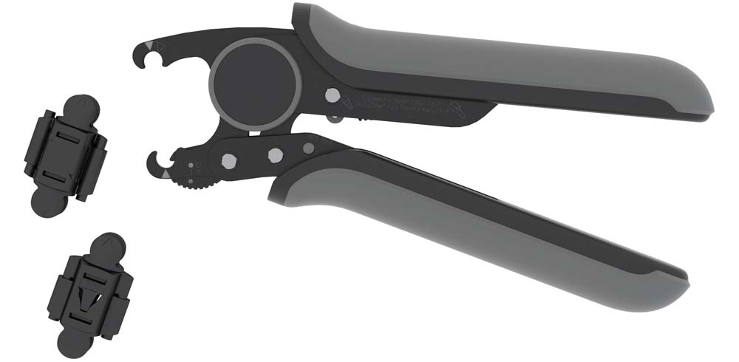
Caption: The new crimp tools are easy to handle and can be adjusted by 360° depending on preference or available space

Image/s: | crimp_tools_pzd_pzu_16-r | Characters: | 1171
File name: | 202304012_pm_crimp_tools_pzd_pzu_16-r_en | Date: | 04-03-2023
About CONTA-CLIP
CONTA-CLIP is one of Europe’s leading manufacturers of electrical and electronic connection elements and cable management solutions. Based in Hövelhof, Germany, the medium-sized, family-run company has been producing electric and electronic connection systems for the process and automation industries since 1978. CONTA-CLIP supplies all industry sectors, focusing on railroad industries, shipbuilding, building automation, conveyor technology, machine and plant engineering and construction, instrumentation and control technology, control panel manufacturing, transformer manufacturing, and environmental technology. The company consists of many specialized branches: CONTA-CONNECT for electric connection technology, CONTA-CABLE for cable management systems, CONTA-ELECTRONICS for electronics and CONTA-CON for PCB edge connectors. Additionally, CONTA-CLIP provides services such as customizing housings and mounting rails, labeling and supplying user-specific electronic components.
Contact:  CONTA-CLIP  Verbindungstechnik GmbH  Franziska Klein  Otto-Hahn-Str. 7  33161 Hövelhof  Germany  Phone: +49 . 5257 . 9833 - 173  Email: franziska.klein@conta-clip.de  Internet: www.conta-clip.com |  | gii die Presse-Agentur GmbH  Immanuelkirchstr. 12  10405 Berlin  Germany  Phone: +49 . 30 . 538 965 - 0  Email: info@gii.de  Internet: www.gii.de

