Press Release

New PTKS 4/SI transformer fuse terminals with push-in connection

The connection technology expert Conta-Clip has expanded its PTKS 4 transformer terminal series with push-in connection for easy installation, adding two transformer fuse terminals. The new models PTKS 4/SI 5x20 and PTKS 4/SI 6.3x32 receive 5x20mm and 6.3x32mm type fuses by means of screw caps. The transformer terminals for 4-mm² wire cross-sections can be mounted on the coil body or on 10 mm x 2 mm aluminum mounting rails. For quick, tool-free contacting, wires are simply pushed into the terminals' connection channels from above. A high-contact-force push-in spring ensures firm, durable fixation and contacting that withstands even severe vibrations and mechanical shocks. Wires can be quickly disconnected by pressing the integrated insulated pusher. Featuring a two-part design consisting of the base terminal with freely accessible solder hooks and a cover, the terminals can also be easily soldered onto the coil wires using automatic soldering methods. Conta-Clip offers terminal covers in various colors, e. g., for marking different voltages. The new terminal series enables test tapping at any potential. Conta-Clip's standard labeling system SB 7.5 can be used to mark the terminals.

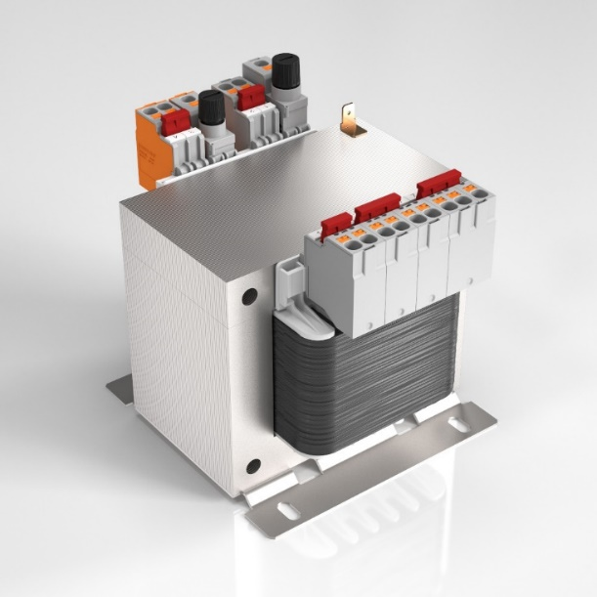
Caption: Transformer terminals and transformer fuse terminals with push-in connection minimize the wiring effort

Image/s: | ptks_4 | Characters: | 1200
File name: | 202304015_pm_ptks_4-si_transformer_terminals_en | Date: | 06-07-2023
About CONTA-CLIP
CONTA-CLIP is one of Europe’s leading manufacturers of electrical and electronic connection elements and cable management solutions. Based in Hövelhof, Germany, the medium-sized, family-run company has been producing electric and electronic connection systems for the process and automation industries since 1978. CONTA-CLIP supplies all industry sectors, focusing on railroad industries, shipbuilding, building automation, conveyor technology, machine and plant engineering and construction, instrumentation and control technology, control panel manufacturing, transformer manufacturing, and environmental technology. The company consists of many specialized branches: CONTA-CONNECT for electric connection technology, CONTA-CABLE for cable management systems, CONTA-ELECTRONICS for electronics and CONTA-CON for PCB edge connectors. Additionally, CONTA-CLIP provides services such as customizing housings and mounting rails, labeling and supplying user-specific electronic components.
Contact:  CONTA-CLIP  Verbindungstechnik GmbH  Franziska Klein  Otto-Hahn-Str. 7  33161 Hövelhof  Germany  Phone: +49 . 5257 . 9833 - 173  Email: franziska.klein@conta-clip.de  Internet: www.conta-clip.com |  | gii die Presse-Agentur GmbH  Immanuelkirchstr. 12  10405 Berlin  Germany  Phone: +49 . 30 . 538 965 - 0  Email: info@gii.de  Internet: www.gii.de

