Press Release

Quick-swap sensor junction for extreme environments

EGE expands its GS series for plug connection of inductive proximity switches with metal-armored cables, adding a new M30 sensor adapter. GS junction boxes are designed for easy and safe connection of inductive sensors with heavy-duty plug connectors. The GS M30 sensor adapter has an extended temperature tolerance up to 90 °C and is made of stainless steel. Featuring a cylindrical M30 design, it is easy to install in dividing walls such as cable duct walls. The GS 125…250 series currently comprises three rugged junction boxes with two, three or four sensor ports for 3-pole K series Lemo plugs. The IP68-protected junctions in an aluminum housing are rolling oil proof and therefore even suitable for operation in industrial environments with emulsion fogs, which often cause short circuits in conventional terminal boxes. Power and communication lines are connected via a rugged multicore TPE cable. This enables correct sensor exchange in demanding industrial applications. EGE provides a wide range of inductive sensors for noncontact positioning, counting and detection of metal objects. The portfolio includes, among others, rolling oil proof PTFE, PP and PEEK sensors, including food industry versions, which are also designed for long lifespans and reliable operation under extreme conditions. Large switching distances up to 170 mm can be implemented.

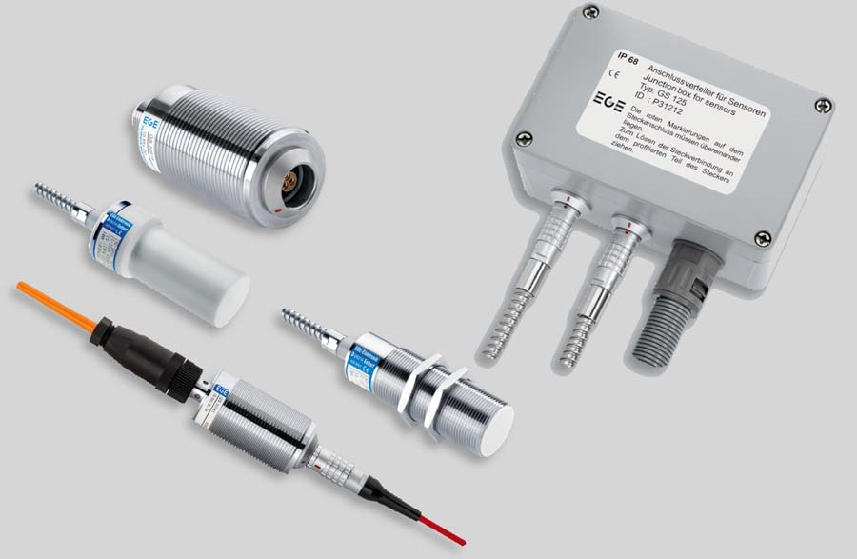
Caption: The rugged junction boxes and the new M30 sensor adapter allow for quick exchange of inductive proximity switches in demanding environments

Image/s: | gs_sensor_junction_2 | Characters: | 1365
File name: | 202304039_pm_gs_junction_box_en | Date: | 10-04-2023
About EGE
EGE-Elektronik Spezial-Sensoren GmbH has been developing and manufacturing special purpose sensors for automation applications since 1976. The company serves leading international producers from a wide range of industries. Its product portfolio includes flow controllers, infrared, opto and ultrasonic sensors, capacitive proximity switches, light barriers and inductive proximity switches. EGE also provides sensors for highly sensitive applications, e.g. hazardous areas. The development department's highly qualified staff cooperates closely with all customers, ensuring continuous product updates and enhancement. A total of 130 employees, including 20 engineers and technicians, generate gross sales of approx. 19.5 million Euros worldwide.
Contact:  EGE-Elektronik Spezial-Sensoren GmbH  Sven-Eric Hiss  Ravensberg 34  24214 Gettorf  Germany  Phone: +49 . 4346 . 4158-0  Email: info@ege-elektronik.com  Internet: www.ege-elektronik.com |  | gii die Presse-Agentur GmbH  Immanuelkirchstr. 12  10405 Berlin  Germany  Phone: +49 . 30 . 538 9650  Email: info@gii.de  Internet: www.gii.de

