Press Release

EMBEDDED VISION SUMMIT: Versatile MIPI camera modules for speedy embedded vision integration

At the EMBEDDED VISION SUMMIT, Vision Components will present the latest additions to its portfolio for fast-track embedded vision integration. The focus will be on its growing MIPI camera range and accessories like the FPGA-based hardware accelerator VC Power SoM, which completes complex image processing calculations and transfers the results directly to a processor board. The module boasts mature FPGA technology and comprehensive image processing functionalities on a footprint of only 28 mm x 24 mm. It can be directly integrated into embedded vision mainboard designs as a module or combined with an I/O board with multiple MIPI interfaces. Using the VC Power SoM, OEMs can employ the full computing power of their preferred embedded processor board for the main application. To further facilitate development work, Vision Components is working on its own FPGA designs that will provide tested-and-proven solutions for applications such as color conversion, 1D barcode identification, epipolar correction, etc.

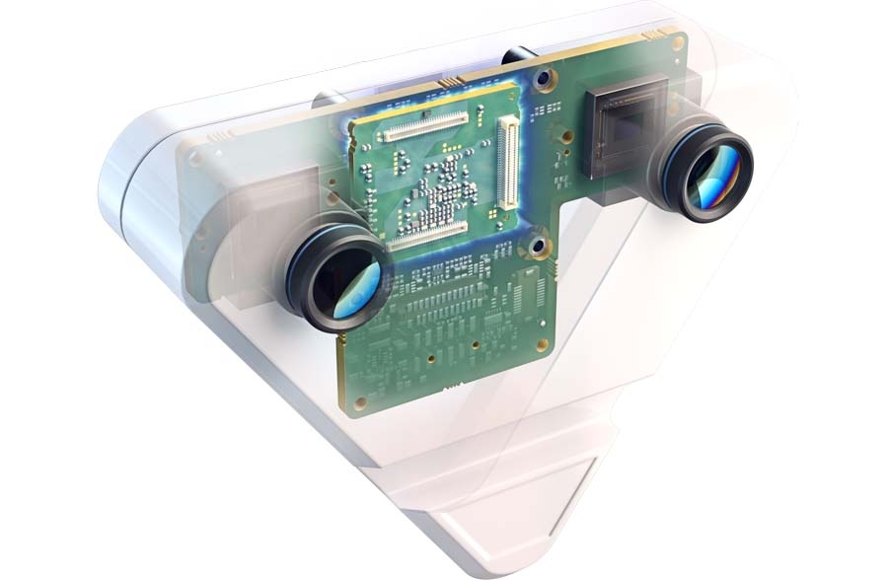
Caption: Sample application with VC Power SoM: stereo camera with direct data processing on the edge device

The German manufacturer is continually expanding its range of image sensor modules for easy integration in MIPI embedded vision applications. New VC MIPI camera modules using SWIR and 3D/ToF sensors, for instance, open up new application areas. The company will also showcase its versatile range of full-fledged embedded vision systems featuring powerful, fast processors from a stamp-sized board camera to enclosed cameras in a rugged housing with ethernet interfaces. All products are developed and produced by Vision Components in Germany and are long-term available and suitable for commercial solutions.
Vision Components at the Embedded Vision Summit
Santa Clara, CA, USA, 22 – 24 May 2023
Booth #417

Image/s: | vc_stereo_camera_case_ghosting | Characters: | 1626
File name: | 202304041_pm_embedded_vision_summit_en | Date: | 04-19-2023
About Vision Components
Vision Components is a leading international manufacturer of embedded vision systems. The freely programmable cameras with powerful onboard CPUs perform image processing tasks on their own without the need for an additional computer. Vision Components offers OEMs versatile Linux-based embedded systems for 2D and 3D image processing, supplied as board cameras or in protective casings. These are complemented by a growing range of ultracompact MIPI camera boards, which connect to a variety of different CPU boards. In addition, Vision Components offers software libraries and develops customized solutions on request. The team of experts can draw on extensive knowledge and over 20 years of experience with imaging applications. The company based in Ettlingen in southwestern Germany was founded in 1996 by Michael Engel, the inventor of the first industrial-grade intelligent camera. More world premieres followed, including the world's first intelligent vision sensors and the first-ever embedded 3D laser profiler. Today, Vision Components has sales offices in the United States and Japan and works with local partners in over 25 countries to provide consistent customer focus and readily available expertise throughout the world.
Contact:  Vision Components GmbH  Jan-Erik Schmitt  Ottostr. 2  76275 Ettlingen  Germany  Phone: +49 . 7243 . 21670  Email: schmitt@vision-components.com  Internet: www.vision-components.com |  | gii die Presse-Agentur GmbH  Immanuelkirchstr. 12  10405 Berlin  Germany  Phone: +49 . 30 . 538 9650  Email: info@gii.de  Internet: www.gii.de

