Press Release

CVPR Expo Vancouver: MIPI camera modules and components for fast-track embedded vision integration

At the IEEE/CVF Conference on Computer Vision and Pattern Recognition (CVPR), Vision Components will present its products for efficient embedded vision designs, highlighting solutions based on the powerful and fast MIPI interface. The German manufacturer offers one of the largest ranges of MIPI camera modules, which are integrated on miniature boards suitable for automatic pick and place and which can be easily integrated in customized designs with single-board computers such as Raspberry Pi, NVIDIA Jetson, DragonBoard, or 96boards. VC MIPI camera modules are now also available with SWIR and 3D/ToF sensors. Another one of VC’s CVPR Expo highlight will be the FPGA-based hardware accelerator VC Power SoM, which completes complex image processing calculations and transfers the results directly to a processor board. The module with a small 28 mm x 24 mm footprint features mature FPGA technology and comprehensive image processing functionalities. It can be directly integrated into embedded vision mainboard designs as a module or combined with an I/O board with multiple MIPI interfaces. Using the VC Power SoM, OEMs can employ the full computing power of their preferred embedded processor board for the main application. Vision Components is developing its own FPGA designs for applications such as pattern recognition, color conversion, 1D barcode identification, epipolar correction, etc., and will be happy to discuss this work and practical applications.

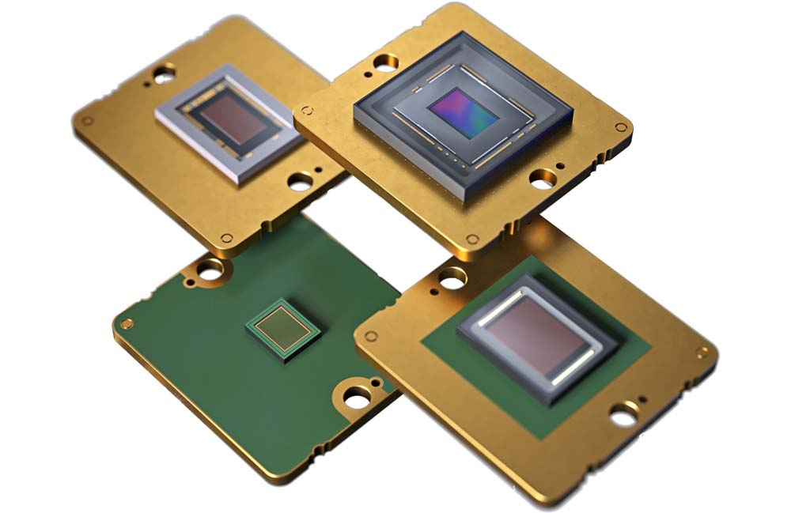
Caption: Vision Components offers one of the most comprehensive portfolios of MIPI camera modules and has lately added four Sony Pregius S global shutter sensors

The company will also showcase its versatile range of full-fledged embedded vision systems featuring powerful, fast processors from a stamp-sized board camera to enclosed cameras in a rugged housing with ethernet interfaces. All products are developed and produced by Vision Components in Germany and are long-term available and suitable for commercial solutions.
Vision Components at the CVPR Expo
Vancouver, Canada, 18 – 22 June 2023
Booth #1012

Image/s: | vc_mipi_camera_modules_lineup_4 | Characters: | 1833
File name: | 202304042_pm_vc_at_cvpr_vancouver_en | Date: | 05-02-2023
About Vision Components
Vision Components is a leading international manufacturer of embedded vision systems. The freely programmable cameras with powerful onboard CPUs perform image processing tasks on their own without the need for an additional computer. Vision Components offers OEMs versatile Linux-based embedded systems for 2D and 3D image processing, supplied as board cameras or in protective casings. These are complemented by a growing range of ultracompact MIPI camera boards, which connect to a variety of different CPU boards. In addition, Vision Components offers software libraries and develops customized solutions on request. The team of experts can draw on extensive knowledge and over 20 years of experience with imaging applications. The company based in Ettlingen in southwestern Germany was founded in 1996 by Michael Engel, the inventor of the first industrial-grade intelligent camera. More world premieres followed, including the world's first intelligent vision sensors and the first-ever embedded 3D laser profiler. Today, Vision Components has sales offices in the United States and Japan and works with local partners in over 25 countries to provide consistent customer focus and readily available expertise throughout the world.
Contact:  Vision Components GmbH  Jan-Erik Schmitt  Ottostr. 2  76275 Ettlingen  Germany  Phone: +49 . 7243 . 21670  Email: schmitt@vision-components.com  Internet: www.vision-components.com |  | gii die Presse-Agentur GmbH  Immanuelkirchstr. 12  10405 Berlin  Germany  Phone: +49 . 30 . 538 9650  Email: info@gii.de  Internet: www.gii.de

