Press Release

Conta-Clip pushes new PRK terminal blocks

Conta-Clip expands its PRK and PSL push-in terminal series, adding various models for 10-mm² wire cross sections. The new PRK 10/2A, /3A and /4A terminal blocks and PSL 10/2A, /3A and /4A protective earth terminals feature up to four wire ports for quick and easy push-in contacting. The practical push-in connection ensures a safe, tool-free insertion of rigid wires or wires with end sleeves and significantly reduces the time spent on wiring. Wires can be quickly disconnected by pressing the integrated pusher. The PE terminals feature a foot contact on both sides to ensure maximum electrical and mechanical reliability. For flexible potential distribution, the PRK terminals provide two cross-connection options. The new terminals, which are designed for a rated voltage of 1000 V at rated currents up to 57 A, are an optimal solution for installations such as string distributors in photovoltaic systems. The PRK push-in series currently covers wire cross sections from 0.2 mm² to 10 mm², with feed-through, PE, disconnect, fused multi-tier, installation and initiator terminals. All insulating materials used are free of harmful substances and have a UL 94 V-0 (self-extinguishing) flammability rating.
Conta-Clip at Hannover Messe, 17 – 21 April 2023
Hall 11, Stand C29

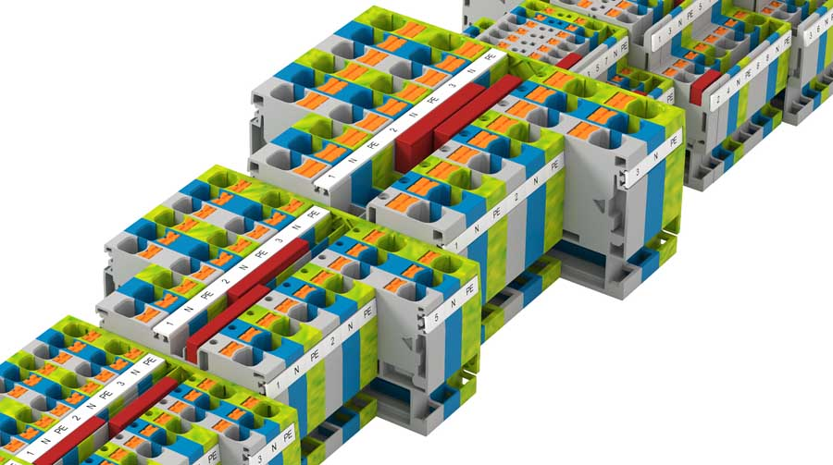
Caption: PRK and PSL push-in terminals from Conta-Clip are now also available for conductor cross-sections up to 10 mm²

Image/s: | prk_reihenklemmen | Characters: | 1210
File name: | 202304044_pm_prk-psl10_terminals_en | Date: | 04-19-2023
About CONTA-CLIP
CONTA-CLIP is one of Europe’s leading manufacturers of electrical and electronic connection elements and cable management solutions. Based in Hövelhof, Germany, the medium-sized, family-run company has been producing electric and electronic connection systems for the process and automation industries since 1978. CONTA-CLIP supplies all industry sectors, focusing on railroad industries, shipbuilding, building automation, conveyor technology, machine and plant engineering and construction, instrumentation and control technology, control panel manufacturing, transformer manufacturing, and environmental technology. The company consists of many specialized branches: CONTA-CONNECT for electric connection technology, CONTA-CABLE for cable management systems, CONTA-ELECTRONICS for electronics and CONTA-CON for PCB edge connectors. Additionally, CONTA-CLIP provides services such as customizing housings and mounting rails, labeling and supplying user-specific electronic components.
Contact:  CONTA-CLIP  Verbindungstechnik GmbH  Franziska Klein  Otto-Hahn-Str. 7  33161 Hövelhof  Germany  Phone: +49 . 5257 . 9833 - 173  Email: franziska.klein@conta-clip.de  Internet: www.conta-clip.com |  | gii die Presse-Agentur GmbH  Immanuelkirchstr. 12  10405 Berlin  Germany  Phone: +49 . 30 . 538 965 - 0  Email: info@gii.de  Internet: www.gii.de

