Press Release

New two-level terminals for 4-mm² cross sections

The German connection technology specialist Conta-Clip introduces new space-saving two-level terminals for rated wire cross sections up to 4 mm². The compact PRKD 4 terminal blocks and the corresponding PSLD 4 PE terminals are available with two or three ports per level and halve the required installation space. In addition to the small footprint, both series are characterized by a large variance and particularly easy handling due to enlarged insertion channels and minimized engaging force. An integrated pusher, which can be operated with light pressure without special tools, is used to quickly disconnect wires. The terminal design and vertical wire insertion from above enable installation close to the wiring channels and thus very compact setups in the field. The high contact force of the push-in spring ensures secure fixation of the wire ends that withstands even strong vibrations and mechanical shocks. All potentials have a test tap for easy measurement. The PE terminals feature PE foot contacts on both sides. The two-level terminals made of non-toxic materials meet the UL 94 V-0 (self-extinguishing) flammability rating. Comprehensive labeling and marking options facilitate installation and servicing.

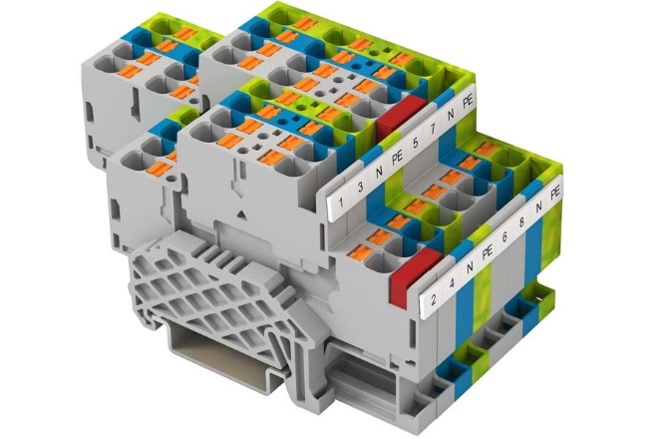
Caption: The new PRKD 4 and PSLD 4 two-level terminal blocks and PE terminals halve the space required for wiring

Image/s: | PRKD4_Klemmleiste_2000px.jpg | Characters: | 1223
File name: | 202304045_pm_prkd-psld4_terminals_en | Date: | 06-28-2023
About CONTA-CLIP
CONTA-CLIP is one of Europe’s leading manufacturers of electrical and electronic connection elements and cable management solutions. Based in Hövelhof, Germany, the medium-sized, family-run company has been producing electric and electronic connection systems for the process and automation industries since 1978. CONTA-CLIP supplies all industry sectors, focusing on railroad industries, shipbuilding, building automation, conveyor technology, machine and plant engineering and construction, instrumentation and control technology, control panel manufacturing, transformer manufacturing, and environmental technology. The company consists of many specialized branches: CONTA-CONNECT for electric connection technology, CONTA-CABLE for cable management systems, CONTA-ELECTRONICS for electronics and CONTA-CON for PCB edge connectors. Additionally, CONTA-CLIP provides services such as customizing housings and mounting rails, labeling and supplying user-specific electronic components.
Contact:  CONTA-CLIP  Verbindungstechnik GmbH  Franziska Klein  Otto-Hahn-Str. 7  33161 Hövelhof  Germany  Phone: +49 . 5257 . 9833 - 173  Email: franziska.klein@conta-clip.de  Internet: www.conta-clip.com |  | gii die Presse-Agentur GmbH  Immanuelkirchstr. 12  10405 Berlin  Germany  Phone: +49 . 30 . 538 965 - 0  Email: info@gii.de  Internet: www.gii.de

