Press Release

CONTA-CLIP grows

CONTA-CLIP is tipped for success. In the last two years, the manufacturer of electrical and electronic connection technology has increased its sales by more than 50 %. In 2022 alone, the company enlarged its workforce at its German headquarters by 36 %. This process is accompanied by the largest investments in the company’s history. CONTA-CLIP is continuously developing new, inventive solutions for cable management and control cabinet wiring with many advantages for users. The innovation potential is reflected in a large number of filed patents. Only recently, CONTA-CLIP announced the worldwide launch of new, particularly easy-to-install transformer terminals with push-in connection for fast, tool-free wiring.

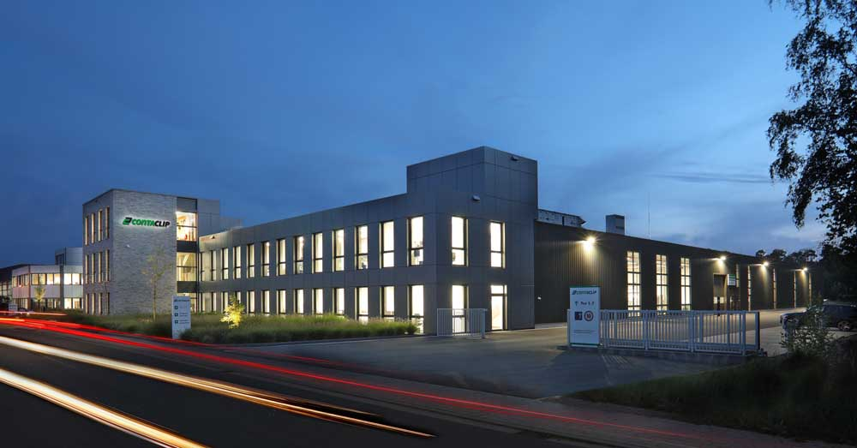
Caption: CONTA-CLIP supplies customers worldwide with connection technology for efficient, comfortable installation from its headquarters in Hoevelhof, Germany

An important new business unit is wireless networking, visualization and remote control of industrial processes. Joerg Nowastowski-Stock, Managing Director Marketing/Sales at CONTA-CLIP, says: “CONTA-CLIP is increasingly developing from a supplier of components to a design and production partner for OEMs, whom we support with EMS and E²MS (Electronic [Engineering and] Manufacturing Services). We are anticipating double-digit percentage growth again this year.”
The family-run company caters to a global market and is at the same time strongly rooted in its region. Bianca Klass, Managing Partner, says: “The ‘Made in Germany’ label continues to earn us great recognition among our customers worldwide. We are pleased that we are also perceived as an attractive employer with a good working atmosphere, short decision-making processes also due to flat hierarchies and good career opportunities for committed employees.”
After the addition of a new plant at its headquarters in 2020, CONTA-CLIP is already nearing full capacity again. As new production areas are being planned, automated production methods and the overarching concern for sustainability will continue to play an important role in the company’s future development.

Image/s: | conta-clip_hoevelhof | Characters: | 1949
File name: | 202304047_pm_conta-clip_growth_en | Date: | 04-12-2023
About CONTA-CLIP
CONTA-CLIP is one of Europe’s leading manufacturers of electrical and electronic connection elements and cable management solutions. Based in Hövelhof, Germany, the medium-sized, family-run company has been producing electric and electronic connection systems for the process and automation industries since 1978. CONTA-CLIP supplies all industry sectors, focusing on railroad industries, shipbuilding, building automation, conveyor technology, machine and plant engineering and construction, instrumentation and control technology, control panel manufacturing, transformer manufacturing, and environmental technology. The company consists of many specialized branches: CONTA-CONNECT for electric connection technology, CONTA-CABLE for cable management systems, CONTA-ELECTRONICS for electronics and CONTA-CON for PCB edge connectors. Additionally, CONTA-CLIP provides services such as customizing housings and mounting rails, labeling and supplying user-specific electronic components.
Contact:  CONTA-CLIP  Verbindungstechnik GmbH  Franziska Klein  Otto-Hahn-Str. 7  33161 Hövelhof  Germany  Phone: +49 . 5257 . 9833 - 173  Email: franziska.klein@conta-clip.de  Internet: www.conta-clip.com |  | gii die Presse-Agentur GmbH  Immanuelkirchstr. 12  10405 Berlin  Germany  Phone: +49 . 30 . 538 965 - 0  Email: info@gii.de  Internet: www.gii.de

