Press Release

XXL-sized precision feeding systems

LOSYCO has expanded its range of services for heavy-duty production logistics: the intra-logistics specialist now also designs and installs customer-specific feeding systems for setup areas and material loading. The new solutions based on the LOXrail floor rail system allow for precise positioning of bulky parts and heavy materials on motor-driven or manually operated platforms with payloads of several tons. The system allows for fully automatic material feeding through interfacing with the plant control system. Applications that demand increased precision, such as laser cutting systems, welding cells or measuring portals, can be equipped with leveling points and limit switches for maximum repeatability. The manufacturer adapts the rail layout to the individual plant or production line for optimal use of space with a large loading capacity. Optionally, rotating platforms, crossings and changes of direction can be implemented for better accessibility of semi-finished products. For high throughput in limited space, the manufacturer can also design special upper and lower carriages with different loading heights and track widths in order to transport raw materials and finished parts independently of each other on the same line. LOSYCO’s scalable feeding systems enable tailor-made solutions for on-point material provision and safe loading and unloading of heavy and large-format workpieces. The floor-level rails pose no obstacles for employees or pallet jacks. The LOSYCO brochure “Loading and unloading with Loxrail®” is available for download at https://www.losyco.com/en/media-library.

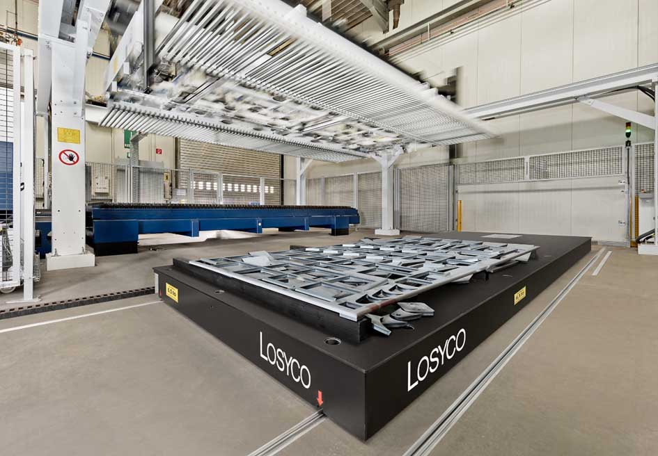
Caption: LOSYCO designs bespoke feeding systems for precise loading and unloading of bulky and heavy parts

Image/s: | plattform_1000 | Characters: | 1607
File name: | 202304059_pm_feeding_systems_en.docx | Date: | 04-25-2023
About Losyco
LOSYCO designs, builds, and installs intra-logistics systems for the manufacturing industry. The company based in Bielefeld, Germany, was founded by experienced engineers in 2016. LOSYCO’s first core product is the LOXrail® floor rail system for easy transport and precise positioning of loads weighing several tons. LOXrail transport platforms can be operated manually or with auxiliary drives. LOSYCO also supplies handling equipment such as chain and roller conveyors, material management and storage systems, as well as sound-proof cabins and machine covers. LOSYCO also supports customers wishing to transform their production processes to lean manufacturing and continuous flow production. LOSYCO is a member of the DRECKSHAGE Family.
Contact:  LOSYCO GmbH  Member of the DRECKSHAGE Family  Manuel Granz  Walter-Werning-Str. 7  33699 Bielefeld  Germany  Tel.: +49 . 521 . 945 643-0  Email: info@losyco.com  Internet: www.losyco.com | gii die Presse-Agentur GmbH  Immanuelkirchstr. 12  10405 Berlin  Germany  Tel.: +49 . 30 . 538 965-0  Email: info@gii.de  Internet: www.gii.de

