Press Release

Production line with comprehensive data acquisition

Intra-logistics specialist LOSYCO has realized a new production line with intelligent process control for a construction machinery manufacturer. For continuous production data acquisition, LOSYCO equipped all stations with networked operator terminals and implemented a central control and evaluation unit with visualization and an MES interface. There, events triggered at the stations by pushbutton input are registered and evaluated – cycle prompts, help requests in the event of material shortage or assembly requirements, and emergency stops. Based on these comprehensive data, the construction machinery manufacturer can optimize the performance of the entire line through targeted process control by efficiently coordinating start, cycle and break times, and organizing the station-related tasks according to how much time each takes. Problems and interruptions of the process flow can be identified early on and corrected, for example, by reassigning tasks or readjusting the quality of components and manufacturing and logistics processes. Designed with 12 workstations on a total length of 165 m, the line can be expanded to up to 17 cycles. It has a maximum towing capacity of 170 tons. Assemblies weighing several tons are placed on special transport platforms running on floor-level rails. A special drag system consisting of tie rods and a chain conveyor moves the transport platforms from station to station. A chain conveyor with a cycle length of 10.15 meters is installed at the end of the line.

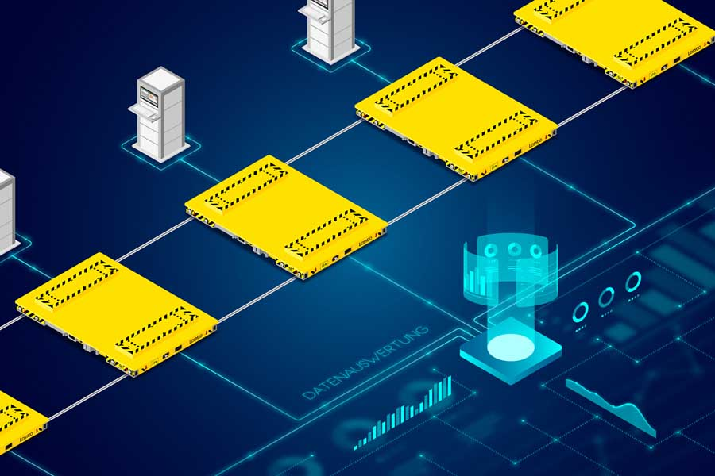
Caption: LOSYCO has designed and implemented a heavy-duty production line with integrated production data acquisition for optimally timed processes

Image/s: | grafik2_prozesssteuerung_2000px.jpg | Characters: | 1513
File name: | 202304060_pm_process_data_acq_en.docx | Date: | 04-25-2023
About Losyco
LOSYCO designs, builds, and installs intra-logistics systems for the manufacturing industry. The company based in Bielefeld, Germany, was founded by experienced engineers in 2016. LOSYCO’s first core product is the LOXrail® floor rail system for easy transport and precise positioning of loads weighing several tons. LOXrail transport platforms can be operated manually or with auxiliary drives. LOSYCO also supplies handling equipment such as chain and roller conveyors, material management and storage systems, as well as sound-proof cabins and machine covers. LOSYCO also supports customers wishing to transform their production processes to lean manufacturing and continuous flow production. LOSYCO is a member of the DRECKSHAGE Family.
Contact:  LOSYCO GmbH  Member of the DRECKSHAGE Family  Manuel Granz  Walter-Werning-Str. 7  33699 Bielefeld  Germany  Tel.: +49 . 521 . 945 643-0  Email: info@losyco.com  Internet: www.losyco.com | gii die Presse-Agentur GmbH  Immanuelkirchstr. 12  10405 Berlin  Germany  Tel.: +49 . 30 . 538 965-0  Email: info@gii.de  Internet: www.gii.de

