Press Release

RAFI expands MICON 5 micro-switch series

With the MICON 5 S, MICON 5 SL, and MICON 5 SAFETY series, RAFI has launched a new generation of robust, ultra-small tactile switches. The extremely compact micro-switches measure just 5.1 x 6.4 x 3.85 mm. Thanks to their optimized sealing system, they achieve IP67 degree of protection and can therefore be installed on PCBs protected by casting, painting, or nanocoating. The extreme temperature resistance from -40°C to +125°C meets current automotive industry standards. High-quality gold contacts ensure permanent switching reliability. The micro-switches are available for operating forces of 1.5 N to 8 N as well as in the extremely long-life MICON 5 SL version. With an operating life of up to ten million actuation cycles, the SL switches are designed for tough applications, e.g. in joysticks and other control devices subject to high stress. The third option in the range is an enhanced-safety version. With identical dimensions, the MICON 5 SAFETY series incorporates two potential-free, separate NC and NO contacts. Due to the two-channel contact system, these models are ideal for safety-critical applications that meet the functional safety requirements of IEC 61508, DIN EN ISO 13849, IEC 62061, IEC 60601, DIN EN ISO 25119, DIN EN 50128, or ISO 26262. Characteristic of all MICON 5 variants is their distinctive tactile feedback. The model series are available with SMT and in some versions THT. The media-resistant design makes them ideal for automated PCB assembly and sealing. There is also an extensive range of accessories with compatible plungers, keycaps, and illumination solutions for all use cases.

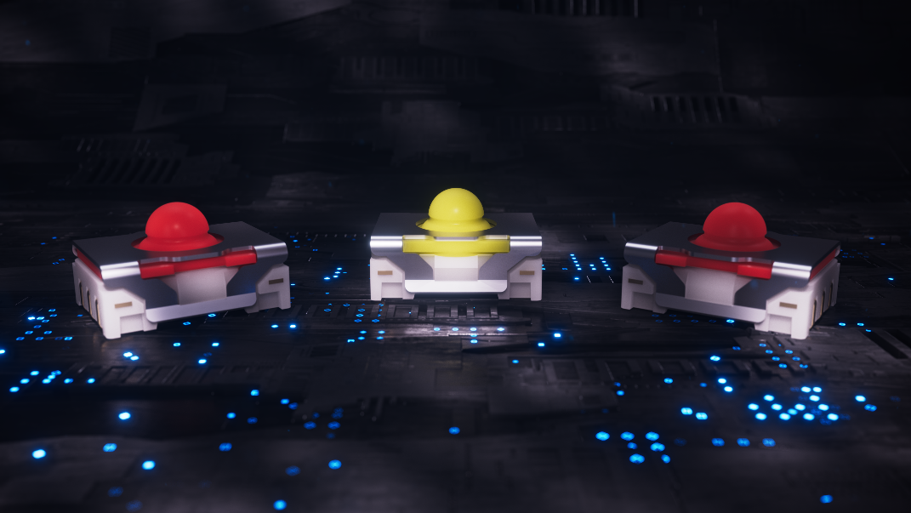
Caption: The extremely compact, media-resistant MICON 5 micro-switches for automated PCB assembly are also available in long-life and safety versions

Image/s: | micon_5_s_varianten_2000.jpg | Characters: | 1625
File name: | 202304061_pm_micon5-familie_en.docx | Date: | 04-25-2023

About the RAFI Group
Founded in 1900, RAFI today develops and produces electromechanical components and systems for human–machine interaction. The range of products includes key switches, switches, touchscreens, control systems and electronic assemblies. RAFI products are employed in many industries including automation, medical technology, machine and plant engineering, road and railway vehicles, household appliances and telecommunication. The RAFI Group operates internationally with more than 2,000 employees at sites in Germany, Europe, China, and the USA. Since 2020, it has been owned by the US investment company Oaktree. Its headquarters are in Berg, Germany.

Contact:
RAFI GmbH & Co. KG
Tatjana Schweitzer
Ravensburger Str. 128–134
88276 Berg, Germany
Phone: +49 751 89-1468
Email: tatjana.schweitzer@rafi-group.com
Web: www.rafi-group.com

